Android Open Source Project: Core Systems Tablet Lockdown Concerning Multiple Manufacturers

The History, Process and Future Directions

Authored by Claire Burn

AOSP On Multiple Manufacturers

The History, Process and Future Directions

Table of Contents

I. Abstract 4

II. Technical Specs 4

III. Introduction & Background Work 4

i) High-Level Requirements – Initial Stories 5

ii) Functional Requirements 5

IV. Navigating This Document 7

Overview of Basic Linux Commands 8

TIPS: 8

Basic Requirements 9

What is Android? 9

What is Linux? 9

V. The Process - Overview 10

Known Issues Encountered 10

Process Walkthrough 11

1) Identify the target Android Tablet that will be the focus of the project. 11

2) Set up Host PC for compilation. 12

Check Installed Java Version 14

Configuring Environment Variables 14

Installing required packages (Ubuntu 14.04) 15

Configuring USB Access 15

Output Directory 15

3) Acquire the kernel source for the target manufacturer 16

Knowing Which Source To Download – POC for Samsung Source 17

Toolchain – Step by Step 20

Building The Kernel 23

Copy needed binaries to your Android repository 24

Kernels for Tablets from other Manufacturers 25

Downloading Android Open Source Project and Swapping in the Custom Kernel 26

Flashing New Tablets: Samsung 27

A Note on Unlocking the Bootloader 27

Installing a custom recovery 27

Windows (only) driver installation - Skip this step if you are using Linux or Mac: 28

Installing Image from recovery 30

claire-yhvh@10.0.100.67 30

BUILDING THE CURRENT NEXUS AOSP 31

Flashing from Android to Core 32

1. Power on the tablet 32

2. Setup tablet for first use 32

3. Enable Developer options 33

4. Connect tablet to Computer via USB Cable 34

5. Start Bootloader 35

6. Unlock Bootloader 36

7. Flash Tablet 36

8. Factory reset the tablet 0

9. Enable network settings 0

Flashing existing Core Tablet with an updated version of Core system 1

1. Navigate to Core Existing Tablet [Reflashing] Folder 1

2. Open Files for Re Flashing tablet 1

3. Factory reset the tablet 1

The Process Concerning Tablets From New Manufacturers 3

Future Steps 4

Take out desired features in kernel and in AOSP 4

Appendix: Communication with Samsung 5

Appendix X: Samsung Region Codes for Firmware and Tablet Versions 6

References 7

# Abstract

**Android AOSP is a project to allow the source code of Android to be freely available to developers and companies to adapt, edit, and add to for commercial purposes. It allows the Android platform to be ported to different devices and it will be a great asset in this project. The aim of this project is to port our existing locked down Android OS to a different style and manufacturer of tablet, namely Samsung. The actual manufacturer is arbitrary, the final goal of this project is to create a process for porting the OS to other tablets for future project and possible market expansion into tablet sales.**

# Technical Specs

**Current AOSP**

|  |  |
| --- | --- |
| **Developed By** | Nhan Nguyen |
| **Build System** | Make |
| **Target Device** | Google Nexus Series / HTC |
| **Target Android Version** | Android 4.x |
| **Target Java Version** | Java 7 |
| **Target JDK** | 1.7.x |

**Proposed AOSP**

|  |  |
| --- | --- |
| **Developed By** | Nhan Nguyen / Claire Burn |
| **Build System** | Make |
| **Target Device** | Samsung |
| **Target Android Version** | Android 5+ (Lollipop -> Marshmallow+) |
| **Target Java Version** | Java 7 & 8 |
| **Target JDK** | 1.7 & 1.8 |

# Introduction & Background Work

The Android Tablet device is a secure portable device which allows an inmate to view their messages, movies and pictures and to listen to music via a headset. Inmates can also browse the media catalogue and purchase items via the media app using virtual or real currency.

The current device used by Core (the Google Nexus by HTC) has built-in security features to restrict access to valid users only and has a 30 day timeout feature which is used to disable stolen devices. When the device is connected to the synchronization service either by Wi-Fi or USB, the inmate messages, pictures, media purchases and device catalogue will be updated.

It is critical to prevent the user from accessing the Home Screen (the Android equivalent to the Desktop) and App Launcher. Only specified applications are allowed to run, preventing the user from executing, downloading or installing any other applications. Settings, notifications and other system features are disallowed.

## High-Level Requirements – Initial Stories

* **Device speakers can be disabled.**
* **Wi-Fi can be disabled.**
* **Microphone can be disabled.**
* **Front Camera can be disabled.**
* **Bluetooth is disabled.**
* **Recovery mode is password protected.**
* **Bootloader is locked.**
* **SD card slot (if applicable) can be disabled.**
* **USB ports can be disabled.**

## Functional Requirements

|  |  |
| --- | --- |
| **Create a custom Home Screen/Launcher** | It is critical to prevent the user from accessing the Home Screen (the Android equivalent to the Desktop) and App Launcher. Only specified applications are allowed to run, preventing the user from executing, downloading or installing any other applications. |
| **Custom Lock Screen** | When the tablet screen is locked by the inmate should be possible to see the inmate’s number or booking number on this lock screen, where either a pattern or password is entered to unlock the device. This is important as many tablets could be left in a syncing area and it would make it more difficult for the inmate to locate their tablet in this area. |
| **Landscape Display Only** | The android device should have its orientation locked to Landscape for all apps. |
| **Completely Hide or Disable bottom bar** | Physical buttons should be used in the Core image for device navigation. In newer versions of Android the bottom bar can give access to both the device settings pages and recent apps. |
| **Suppress system notifications windows** | All messages should be communicated to the inmate via the custom launcher application. This gives more control over what is displayed to the inmate. Over Wi-Fi the officer can choose to send the inmate a full screen message at any time. |
| **30 day countdown period** | If the device is not connected within the 30 countdown period the device will be disabled.  A background service will check periodically for this requirement. |
| **Locked down device** | When the device is ‘disabled ‘or ‘locked down’ all functionality will be deactivated and button presses ignored. |
| **Stolen Device** | If a device is reported stolen the device will be locked down the next time it is connected to a kiosk or Wi-Fi. |
| **Countdown Period Reset** | When the device is plugged into the kiosk and it has completed synchronization the countdown period will be reset. If the device is not reported as stolen the login menu will be activated again. |
| **Disable access to Mass Storage Device** | There should be no access to the USB storage on either SD-card or system partitions from a PC. The device data should only be accessible by Core System software. If someone plugs the device into a standard PC the data must be protected. |
| **Restrict users so they can’t install applications themselves** | Do not allow installation of any apps from APKs which are not signed by Core Systems.  Restrict users in the use of installed applications.  Officers can decide whether an individual inmate is allowed to use a particular application. |
| **Block user from changing System Settings** | The user should have no access to the standard android system settings pages. A new user settings application can be run from the custom launcher. This will include the ability to change their screen lock security and view their available balance. |
| **Remote Monitoring** | It is extremely important to remotely monitor the Android device to determine its current status, and allow an audit of the devices. |
| **Custom Image Creation** | Once an image for a device has been locked down and any test inmate data has been removed, a custom rom for that device will be backed up. This rom can then be used to image the rest of the android devices of that type. |
| **Password protected recovery mode** | If the bootloader on the devices are locked it can be ensured that only our custom rom images are loaded onto the Android devices, by password protecting the recovery mode or at least provide some form of a challenge-handshake authentication process. Additionally we could specify that only our signed custom images could be flashed too. |
| **Deactivate the long press Home** | This can give access to recent apps. This might not be a problem but we might want some running apps to remain hidden. |
| **Maintenance Option** | Maintenance options allow you to send the device to sleep and wake it up at specific times. |
| **Peripheral lockdown** | Wi-Fi, Bluetooth, Camera, Auto-Orientation, Flight-mode, Sound. For security reasons inmates should only have access to the hardware that the individual facility allows. It could possibly be more cost effective to provide a tablet device that has no possibility of using a camera on it as it has been disabled at a low level, rather than trying to source an android device with no physical camera on it |
| **Remote Configuration** | Remotely deploy update lockdown configuration via sync service. |
| **Secure Communication** | All communication to and from the device are to be implemented through a secure ADB wrapper client server application. In order for the commands or transfer to be executed, a security token or valid credentials must be passed. |

# Navigating This Document

# Overview of Basic Linux Commands

|  |  |
| --- | --- |
| **cat** | Sends file contents to standard output. This is a way to list the contents of short files to the screen. It works well with piping. Basically outputs the contents of a file to the terminal. |
| **cd** | Change directory. |
| **cp** | Copy files. For example $ cp <path to source file> <path to destination> |
| **dd** | Disk duplicate. The manual page says this command is to “Convert and copy a file”, but although used by more advanced users, it can be a very handy command. The “if” means input file, “of” means output file. |
| **Df** | Show the amount of disk space used on each mounted filesystem. |
| **Less** | Similar to the cat command, but the user can page up and down through the file. Displays the contents of a text file. |
| **Locate** | A fast database driven file locator. Locates files within the filesystem if given a filename. |
| **Logout** | Logs the current user off the system. |
| **Ls** | List files in the current directory. |
| **Mv** | Move or rename files; syntax is $ mv <source> <destination> |
| **pwd** | Show the name of the current working directory |
| **shutdown** | Shuts the system down. |
| **Tar –zxvf <tarball name>** | Extracts files from a compressed package. Similar to zip files. |
| **Apt-get install** | Installs packages from the agreed repository dependent on the flavour of Linux being used. |
| **uname –a** | Check the architecture of your machine. |
| **man <command>** | Opens the manual page for a certain command if you are unsure. |

### TIPS:

|  |
| --- |
| * Anything in this document with a ‘ $ ‘ before it indicates a command that should be input into the Linux terminal. Each line with a ‘$’ before it should be input separately, and the ‘$’ should not be included, it is simply a placeholder to indicate that this is a command line instruction. * The text editor used for examples in this document is Vim (Vi Improved). If you do not have it, get it on your Linux system by typing: $ sudo apt-get install vim.     **Note:** .sh files are executable shell files called scripts (usually BASH). You can run these by typing **./** before the name of the script. E.g. if you have a BASH script named *build_kernel.sh*, it would be executed like so:  $ ./build_kernel.sh |

# Basic Requirements

To compile and build a new image of the Android operating system, two things are required:

* The kernel source code for the specific device for which you wish to build an image.
* The open sourced Android source code, which can be modified as needed.

## What is Android?

Android is an open source software stack created for a wide array of devices with different form factors. The primary purposes of Android are to create an open software platform available for carriers, OEMs, and developers to make their innovative ideas a reality and to introduce a successful, real-world product that improves the mobile experience for users.

We also wanted to make sure there was no central point of failure, where one industry player could restrict or control the innovations of any other. The result is a full, production-quality consumer product with source code open for customization and porting.

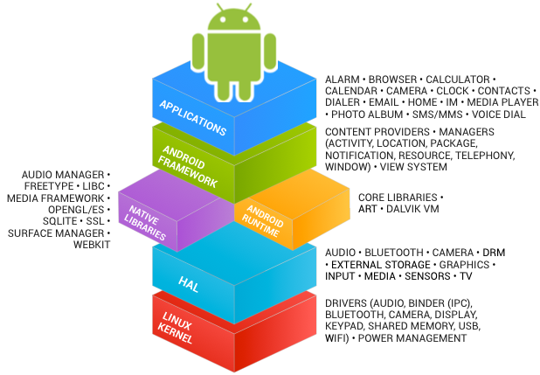

## What is Linux?

Linux or, less frequently, is a Unix-like and mostly POSIX-compliant computer operating system assembled under the model of free and open-source software development and distribution.

When you boot an Android device, the Linux kernel loads just like it would on a Linux distribution. However, much of the other software is different. Android doesn’t include the GNU C Library (glibc) used on standard Linux distributions, nor does it include all of the GNU libraries you’d find on a typical Linux distribution. It also doesn’t include an X server like Xorg, so you can’t run standard graphical Linux applications.

# The Process - Overview

* **Identify the target Android Tablet that will be the focus of the project.**
* **Set up host PC for compilation.**
* **Acquire the kernel source code for the target manufacturer.**
* **Determine requirements for the end product.**
* **Compile kernel with features enabled/disabled.**
* **Flash new image.**

# Known Issues Encountered

* When downloading the Samsung source code, when the model number (the first 5 digits seems to be optimal, but again this is educated guessing) is entered into the search of the Samsung Open Source Resource Centre, several versions of source code appear. I am not entirely sure how to determine which version of source code to download in this instance, and there does not seem to be any adequate documentation on it. I asked Stack Overflow, RootzWiki and the Samsung Open Source Resource Centre themselves, with no adequate answer.
* I could not locate the Android Debug Bridge (adb) source code within the Samsung source for the SM-T555, and so the adb functionality may be limited.
* A salient question for NCCSoft would be to ask them which branch of AOSP to begin developing from and making modifications to. Builds of the unmodified original AOSP can be found here: <https://source.android.com/source/build-numbers.html#source-code-tags-and-builds>.
* In the ‘Copy needed binaries to your Android repository’ section of this document, extra steps may be required to make your device show up in the list of devices. Nhan has developed a way to do this for the existing tablets, and he should be consulted as to the steps to make this work for new tablets, as the author of this doc came up against time constraints.

# Process Walkthrough

## Identify the target Android Tablet that will be the focus of the project.

It is important to know the hardware for which you will be compiling a custom kernel. This will have a knock on effect on everything else that is done during the process of loading the locked down Android OS. It is useful to locate several pieces of information on the hardware:

* The serial number of the device
* The manufacturer
* The model number
* Baseband version

|  |  |  |
| --- | --- | --- |
| **Data Point** | **Format** | **Explanation** |
| Serial Number of the Device (also called an International Mobile Equipment Identity (IMEI)) | 15-digit unique number | Settings > About Device > Status > IMEI. This is a uniquely identifiable number for your tablet. |
| Manufacturer | A name i.e. Samsung | This will heavily influence where you download your source code from, and which drivers you include within your final image, as these vary by manufacturer. |
| Model Number | [With Samsung] Two letters, then a string of 10/11 variable letters/digits. E.g. SM-T810NZKEDBT | IMPORTANT: For Galaxy Tab, enter the first 6 digits/letters of the model number into the search box when searching for an open source download. |
| Baseband version | A three letter code e.g. LFB | Baseband, controls cellular reception and some aspects of WiFi. Think of it as your radio. You can access the current version in Settings/About Device > Tablet. |

## Set up Host PC for compilation.

**Hardware requirements**

Your development workstation should meet or exceed these hardware requirements:

* A 64-bit environment is required.
* At least 100GB of free disk space for a checkout of AOSP or the expansion of the source on a Linux machine, 150GB for a single build, and 200GB or more for multiple builds. If you employ ccache, you will need even more space.
* A Linux in a virtual machine will need at least 16GB of RAM/swap.

**Software requirements**

You workstation must have the software listed below.

**Operating system**

Android is typically built with a Linux or Mac OS operating system. It is also possible to build Android in a virtual machine on unsupported systems such as Windows, however this is not recommended.

**Linux – Minimum Requirements**

* For building for Android 6.0 (Marshmallow) - Ubuntu 14.04 or newer.
* For building for Android 5.x (Lollipop): Ubuntu 12.04 or newer.

**Java Development Kit (JDK)**

Please note, since there are no available supported OpenJDK 8 packages for Ubuntu 14.04, the Ubuntu 15.04 packages must be installed manually. See [JDK for Ubuntu LTS 14.04](https://source.android.com/source/initializing.html#for-ubuntu-14-04) for precise instructions.

* For building for Android 5.x (Lollipop) & Android 6.0 (Marshmallow): Ubuntu - Java JDK 7

**Other Key Packages**

* Python 2.6 or newer from [python.org](http://www.python.org/download/) (do NOT use Python 3)

$ apt-get install python2.7

* GNU Make 3.81 or newer from [gnu.org](http://ftp.gnu.org/gnu/make/).

$ apt-get install make

* Git 1.7 or newer from [git-scm.com](http://git-scm.com/download)

$ apt-get install git

To check if a program is already installed type the program name followed by --version or -v

**Setting up a Linux build environment**

**Installing the JDK For Ubuntu LTS 14.04+**

Try to run the following:

$ cd /opt/

$ wget --no-cookies --no-check-certificate --header "Cookie: gpw_e24=http%3A%2F%2Fwww.oracle.com%2F; oraclelicense=accept-securebackup-cookie" "http://download.oracle.com/otn-pub/java/jdk/7u79-b15/jdk-7u79-linux-x64.tar.gz"

$ tar zxvf jdk-7u79-linux-x64.tar.gz

If this does not work, navigate to the site <http://www.oracle.com/technetwork/java/javase/downloads/jdk7-downloads-1880260.html> and download the JDK 7 for Linux tar.gz file.



Remember, you may obtain the architecture for your machine with:

$ uname –m

Navigate to the directory where the tar.gz file is located (probably Downloads), and type the following:

$ sudo cp jdk-7u79-linux-x64.tar.gz /opt/

$ cd /opt/

$ tar zxvf jdk-7u79-linux-x64.tar.gz

If you have multiple versions of Java installed, you can choose the version you would like to use by entering the following commands. Choose Java JDK 7.

$ sudo update-alternatives --config java  
$ sudo update-alternatives --config javac

## Check Installed Java Version

Use following command to check which version of Java is currently being used by system. The correct version of Java should be 1.7.0_79 for this installation guide.

$ java –version

## Configuring Environment Variables

Most of Java based application’s uses environment variables to work. Use the following commands to set up these variable properly. It’s also good to add following commands to any start-up script like ~/.bashrc or ~/.bash_profile.

* Setup **JAVA_HOME** Variable

$ export JAVA_HOME=/opt/jdk1.7.0_79

* Setup **JRE_HOME** Variable**#**

$ export JRE_HOME=/opt/jdk1.7.0_79/jre

* Setup **PATH** Variable

$ export PATH=$PATH:/opt/jdk1.7.0_79/bin:/opt/jdk1.7.0_79/jre/bin

## Installing required packages (Ubuntu 14.04)

These packages are for 64 bit versions of Ubuntu; make sure that the version of Linux you are running is 64-bit before proceeding. Run the following commands separately: if any of them do not work, install each package individually or look for more up to date versions of the same package; all of these are necessary for a working Android system.

$ sudo apt-get install git-core gnupg flex bison gperf build-essential

$ sudo apt-get install zip curl zlib1g-dev gcc-multilib g++-multilib libc6-dev-i386

$ sudo apt-get install lib32ncurses5-dev x11proto-core-dev libx11-dev lib32z-dev ccache

$ sudo apt-get install libgl1-mesa-dev libxml2-utils liblz4-tool xsltproc unzip

## Configuring USB Access

Under GNU/Linux systems (and specifically under Ubuntu systems), regular users can't directly access USB devices by default. The system needs to be configured to allow such access.

The recommended approach is to create a file at /etc/udev/rules.d/51-android.rules (as the root user).

To do this, run the following command to download the **51-android.rules** file attached to the Android Open Source site, modify it to include your username where it says <username>, and place it in the correct location:

$ wget -S -O - http://source.android.com/source/51-android.rules | sed "s/<username>/$USER/" | sudo tee >/dev/null /etc/udev/rules.d/51-android.rules; sudo udevadm control --reload-rules

Those new rules take effect the next time a device is plugged in. It might therefore be necessary to unplug the device and plug it back into the computer.

## Output Directory

By default, the output of each build is stored in the **out/** subdirectory of the matching source tree.

## Acquire the kernel source for the target manufacturer

You will need 3 things for this stage:

* The kernel. Kernel source code is under GNU GPL open source license so vendors (e.g. Sony, HTC, Samsung, LG) have to release it. You can find your appropriate kernel source code from mentioned websites:
  + For Sony: <http://developer.sonymobile.com/>
  + For Samsung: <http://opensource.samsung.com/>
  + For HTC: <http://www.htcdev.com/>
  + For LG: <http://www.lg.com/global/support/opensource/index>
* The toolchain for compiling the kernel and cross-compiling. There are several ways to ascertain which toolchain is needed. Firstly, look in ‘README_Kernel.txt’ which will be located within the downloaded source code for Samsung devices. If a toolchain is available and downloaded already, it may be in /prebuilts/gcc/linux-x86/arm/, or look at <https://android.googlesource.com/platform/prebuilts/gcc/linux-x86/arm/> for a list of all available toolchains. The README_Kernel.txt file should specify which version to use.

### Knowing Which Source To Download – POC for Samsung Source

First, locate the model number of the tablet that has been acquired. The model number should have a format of “SM-YYYY” where Y is a digit of some description. E.g. SM-T555. Model numbers can also be found on Amazon when purchasing the tablets, or if the make of the tablet is known, by simply Googling this. Navigate to <http://opensource.samsung.com/reception.do> and enter the model number in the search space. If no results are returned, try shortening the model number, and if this still returns no results, then there is no open source code available for the specific model of Samsung tablet; but this should not be the case.

Ignore the fact that the ‘Classification’ field says ‘Mobile Phone’; this is a mistake on Samsung’s part. A few results may be returned. If this is the case, locate the first open source instance with the literal letters “XX” “XW” or “XA” somewhere in the “Version” field string (but most likely “XX”). The format of the Version field should be “YYYYXXxxxxxx” where Y is the last four characters of the model number, followed by two ‘X’s followed by a further six character code which represents the build version. The two ‘X’s symbolise the region, which in this case is Europe.

Click on the Source Code link and download the .zip file. This should all be done on your Linux Box to avoid complications.



**Decompressing the Kernel Tarball**

Within the downloaded source (once you’ve unzipped it), there should be a file called ‘Kernel.tar.gz’.

|  |  |
| --- | --- |
| Create a new directory to extract the kernel to: | $ mkdir kernel |
| Extract the kernel: | $ tar –zxvf Kernel.tar.gz –C kernel |
| Change directory to where the kernel is located: | $ cd kernel/ |

This process is exactly the same for the other .tar.gz files within the original zip file. E.g. Platform.tar.gz.

**Setting up the toolchain**

* This toolchain is only used to build the kernel.
* This toolchain may or may not be included in the Android source package. ($ANDROID_ROOT/prebuilts/gcc/linux-x86/arm/arm-eabi-4.*)

Within the downloaded source code there should be a file named README_Kernel.txt. Open this in your text editor of choice and follow the instructions inside. For example:

###########################################################################

1. How to Build

- get Toolchain

From android git server , codesourcery and etc ..

- arm-eabi-4.8

- edit Makefile

edit "CROSS_COMPILE" to right toolchain path(You downloaded).

EX) export CROSS_COMPILE= $(android platform directory you download)/android/gcc/prebuilts/linux-x86/arm/arm-eabi-4.8/bin/arm-eabi-

Ex) export CROSS_COMPILE=/usr/local/toolchain/arm-eabi-4.8/bin/arm-eabi- // check the location of toolchain

$ export CROSS_COMPILE=(compiler path)

$ export ARCH=arm

$ mkdir output

$ make -C $(pwd) O=output msm8916_sec_defconfig VARIANT_DEFCONFIG=msm8916_sec_gt510wifi_eur_defconfig SELINUX_DEFCONFIG=selinux_defconfig

$ make -C $(pwd) O=output

$ cp output/arch/arm/boot/zImage arch/arm/boot/zImage

2. Output filesS

- Kernel : output/arch/arm/boot/zImage

- module : output/drivers/*/*.ko

3. How to Clean

$ cd output

$ make clean

################################################################################

*This is an example of what may be in the README_Kernel file.*

In this instance, the version of the toolchain required is arm-eabi-4.8. This can be seen in the How To Build section of the above text.

TOOLCHAINS CAN BE DOWNLOADED HERE:

<https://android.googlesource.com/platform/prebuilts/gcc/linux-x86/arm/>

## Toolchain – Step by Step

**\*\*\* 28/04/16 C.B. – I have created a script to automatically ascertain the required toolchain version and download & install it. It is named get_toolchain in the directory I have left at and needs to be placed in the same directory as the README_Kernel.txt file. Then run the following commands. \*\*\***

BEFORE YOU RUN THE SCRIPT, SKIP TO THE ‘BUILDING THE KERNEL’ SECTION OF THIS DOC AND FOLLOW THE INSTRUCTIONS.

$ chmod 777 get_toolchain

$ ./get_toolchain

**Step 1 – Make sure you have a bashrc**

Make sure that you have a bashrc file by typing the following and ensuring that something comes up when this command is run:

$ ls -la ~ | grep .bashrc

The bashrc file is a file full of environment settings for Linux. You will need to add to this later. If nothing is returned when that command is run, create a bashrc by:

$ cd ~

$ sudo cp /etc/skel/.bashrc .

OR

$ touch ~/.bashrc

#### **Step 2 – Ensure that the kernel does not build…… yet.**

Run the script ‘build_kernel_test.sh’ by navigating to the folder where the script exists (it should just be in extracted kernel directory), and typing:

$ ./build_kernel_test.sh

If there is an error involving the location of the toolchain, or if the Makefile (this will come up as a ‘make’ or ‘sub make’ error) is looking for a different version of the toolchain, simply download the appropriate version from <https://android.googlesource.com/platform/prebuilts/gcc/linux-x86/arm/> and continue with this guide. However, make sure to actually read the error message that comes back; the kernel always will tell the user what the problem is. The lines that are important are usually prefixed with the term ‘Error:’.

**Step 3 - Copy the cross compiling tool package to /opt/toolchains**

**Either Do:**

If the '/opt/toolchains' directory does not exist in host pc, then create the directory by doing the following:

$ sudo mkdir /opt/toolchains

Then, copy the downloaded toolchain code to this newly created directory and navigate to it:

$ sudo cp arm-eabi-4.8.tar.gz /opt/toolchains

$ cd /opt/toolchains

#### Decompress the cross tool with tar command

$ cd /opt/toolchains

$ sudo tar -xvf arm-eabi-4.8.tar.gz

If you had already decompressed the tar file, the commands are simply as follows:

$ sudo mkdir /opt/toolchains

$ sudo cp –r arm-eabi-4.8 /opt/toolchains

#### Add the cross compiler to the Path in your environment file by modifying your ~/.bashrc file to add a new path with your text editor of choice. Simply add these lines at the end of the file.

$ export ARCH=arm

$ export PATH=${PATH}:/opt/toolchains/arm-eabi-4.8/bin

$ export CROSS_COMPILE=arm-eabi-

To apply this change, login again or restart the .bashrc

$ source ~/.bashrc

**OR THIS:**

Assuming you don't have a toolchain downloaded already, you can download it by running the following commands:

git clone https://android.googlesource.com/platform/prebuilts/gcc/linux-x86/arm/arm-eabi-4.8 toolchain

export ARCH=arm

export SUBARCH=arm

export CROSS_COMPILE=`pwd`/toolchain/bin/arm-eabi-

For 64 bit devices (using Marshmallow (not applicable for our use case, but perhaps in future)), use the appropriate toolchain:

git clone https://android.googlesource.com/platform/prebuilts/gcc/linux-x86/aarch64/aarch64-linux-android-4.9 -b marshmallow-release toolchain64

export ARCH=arm64

export SUBARCH=arm64

export CROSS_COMPILE=`pwd`/toolchain64/bin/aarch64-linux-android-

**Step 4 – Check the toolchain is set up properly**

#### Check the tool-chain path to see if it is set up correctly or not by typing the following.

$ arm-eabi-gcc -v

This should give a result of something similar to the below code if it is set up correctly:

Using built-in specs.

COLLECT_GCC=arm-eabi-gcc

COLLECT_LTO_WRAPPER=/opt/toolchains/arm-eabi-4.8/bin/../libexec/gcc/arm-eabi/4.8/lto-wrapper

Target: arm-eabi

Configured with: /tmp/AOSP-toolchain/build/../gcc/gcc-4.8/configure --prefix=/tmp/toolchain-build-eabi/prefix --target=arm-eabi --host=x86_64-linux-gnu --build=x86_64-linux-gnu --with-gnu-as --with-gnu-ld --enable-languages=c,c++ --with-gmp=/tmp/toolchain-build-eabi/temp-install --with-mpfr=/tmp/toolchain-build-eabi/temp-install --with-mpc=/tmp/toolchain-build-eabi/temp-install --with-cloog=/tmp/toolchain-build-eabi/temp-install --with-isl=/tmp/toolchain-build-eabi/temp-install --with-ppl=/tmp/toolchain-build-eabi/temp-install --disable-ppl-version-check --disable-cloog-version-check --disable-isl-version-check --enable-cloog-backend=isl --with-host-libstdcxx='-static-libgcc -Wl,-Bstatic,-lstdc++,-Bdynamic -lm' --disable-libssp --enable-threads --disable-nls --disable-libmudflap --disable-libgomp --disable-libstdc__-v3 --disable-sjlj-exceptions --disable-shared --disable-tls --disable-libitm --with-float=soft --with-fpu=vfp --with-arch=armv5te --enable-target-optspace --with-abi=aapcs --enable-initfini-array --disable-nls --prefix=/tmp/toolchain-build-eabi/prefix --with-sysroot=/tmp/toolchain-build-eabi/prefix/sysroot --with-binutils-version=2.23 --with-mpfr-version=3.1.1 --with-mpc-version=1.0.1 --with-gmp-version=5.0.5 --with-gcc-version=4.8 --with-gdb-version=7.6 --with-gxx-include-dir=/tmp/toolchain-build-eabi/prefix/include/c++/4.8 --with-bugurl=http://source.android.com/source/report-bugs.html --disable-bootstrap --disable-libquadmath --enable-plugins --enable-libgomp --disable-libsanitizer --enable-gold --enable-graphite=yes --with-cloog-version=0.18.0 --with-isl-version=0.11.1 --enable-eh-frame-hdr-for-static --with-arch=armv5te --disable-gold --disable-libgomp --program-transform-name='s&^&arm-eabi-&'

Thread model: single

gcc version 4.8 (GCC)

## Building The Kernel

If building manually (i.e. not using the ‘get_toolchain’ script provided, which is highly recommended), make sure that the following instructions are adhered to:

$ vim build_kernel.sh

In this file, delete the text SELINUX_DEFCONFIG=selinux_defconfig , but nothing else.

From the root directory of the Samsung source, do:

$ cd arch/arm/configs/

Edit the first two defconfig files located at /arch/arm/configs/ by typing:

$ vim <put name of defconfig here>

Once in Vim, type /CONFIG_SECURITY_SELINUX/ and press Enter. If the term is found, then enter Insert Mode by pressing ‘i’, and set **CONFIG_SECURITY_SELINUX=n** if it is not already set to this. If the term is not found, add it in at any point in the file on a new line. Additionally, add the following line in anywhere in the file on a newline: **CONFIG_USB_DEBUG=y.**

Then, exit Vim by typing this and then pressing Enter: :wq!

Then go to the root of the source code directory, where the “build_kernel.sh” script is located.

$ cd ../../../

$ vim build_kernel.sh

If this script contains a reference to SELinux, delete this e.g. “SELinux = x”. Save it as described above, and exit Vim. The run the kernel build script:

$ ./build_kernel.sh

**\*\*\* If you are using the get_toolchain script that I created, simply type: \*\*\***

$ ./get_toolchain_v1.sh

The output files will be located in a new directory named **output/** in the same directory as the kernel build script.

To begin the build, simply type the following (strictly after doing the above):

$ make ARCH=$ARCH CROSS_COMPILE=$CROSS_COMPILE –j4

## Copy needed binaries to your Android repository

For building a new boot image with the compiled kernel, the kernel binary “zImage” (located in **output/arch/arm/boot/zImage**) has to be renamed “kernel” and placed in the corresponding device/samsung/<device> folder. Also the “.dtb” files (**located in arch/arm/boot/dts/**) have to be copied to the corresponding device/samsung/<device>/dtbs folder in the AOSP source.

For environment setup instructions, see the [AOSP build instructions](http://developer.sonymobile.com/knowledge-base/open-source/open-devices/aosp-build-instructions/). To generate the images enter the following commands:

$ source build/envsetup.sh && lunch

When prompted, pick the number corresponding to your device in the list displayed and press enter.  
To start the build, type:

$ make –j4 bootimage

**Note**: The build will take some minutes to complete.

## Kernels for Tablets from other Manufacturers

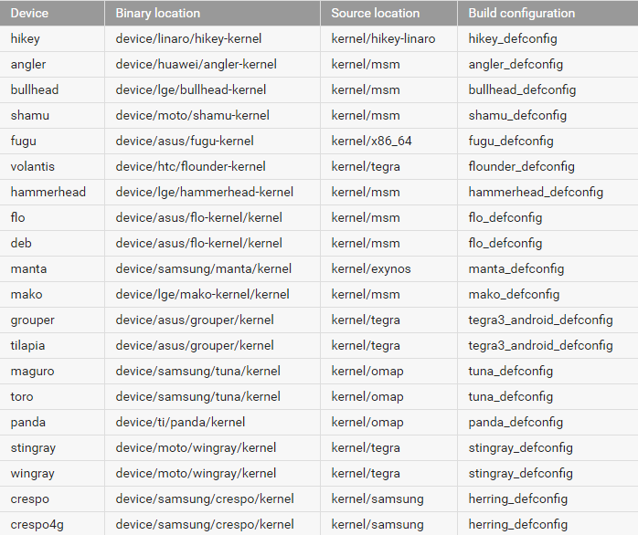

If we are focusing on Samsung devices, here are the codenames on AOSPand the devices they equate to:

|  |  |  |
| --- | --- | --- |
| **Codename** | **Device** | **Source** |
| Manta | Google Nexus 10 | https://android.googlesource.com/device/samsung/manta/ |
| Tuna (Maguro)  [GSM Version] | Samsung Galaxy Nexus | https://android.googlesource.com/device/samsung/tuna/ |
| Tuna (Toro)  [CDMA Version] | Samsung Galaxy Nexus | https://android.googlesource.com/device/samsung/tuna/ |
| Crespo | Samsung Nexus S | https://android.googlesource.com/device/samsung/crespo/ |

# Downloading Android Open Source Project and Swapping in the Custom Kernel

To work with the Android code, you will need to use both Git and Repo. In most situations, you can use Git instead of Repo, or mix Repo and Git commands to form complex commands. Using Repo for basic across-network operations will make your work much simpler, however.

**Git** is an open source version-control system designed to handle very large projects that are distributed over multiple repositories. In the context of Android, we use Git for local operations such as local branching, commits, diffs, and edits. One of the challenges in setting up the Android project was figuring out how to best support the outside community--from the hobbyist community to large OEMs building mass-market consumer devices. We wanted components to be replaceable, and we wanted interesting components to be able to grow a life of their own outside of Android. We first chose a distributed revision control system, then further narrowed it down to Git.

**Repo** is a repository management tool that we built on top of Git. Repo unifies the many Git repositories when necessary, does the uploads to our revision control system, and automates parts of the Android development workflow. Repo is not meant to replace Git, only to make it easier to work with Git in the context of Android. The repo command is an executable Python script that you can put anywhere in your path. In working with the Android source files, you will use Repo for across-network operations. For example, with a single Repo command you can download files from multiple repositories into your local working directory.

**Gerrit** is a web-based code review system for projects that use git. Gerrit encourages more centralized use of Git by allowing all authorized users to submit changes, which are automatically merged if they pass code review. In addition, Gerrit makes reviewing easier by displaying changes side by side in-browser and enabling inline comments.

For the purposes of this guide, I downloaded the AOSP used for previous Core Systems tablet development from Stash.

This can be found from the internal Core network at: <http://10.0.20.100:7990/projects/ALI/repos/aosp/browse>

The username and password can be found at:

From here, go to the three dots in the left hand vertical taskbar, and click on **‘Clone’**. Copy the address that comes up and go into Git.

$ git clone <http://admin@10.0.20.100:7990/scm/ali/aosp.git>

This will clone the repository to your local machine and may take some time. After the download is complete, swap your modified and built kernel for the kernel in this AOSP project.

You can include the **TARGET_PREBUILT_KERNEL** variable while using “make boot image” (or any other make command line that builds a boot image). This variable is supported by all devices as it is set up by editing **device/common/populate-new-device.sh**. For example:

$ export TARGET_PREBUILT_KERNEL=$your_kernel_path/arch/arm/boot/zImage-dtb

## Flashing New Tablets: Samsung

**WARNING: The following instructions are purely theoretical and have not been done in practise. More research is recommended before attempting this and the author of this paper accepts no legal or financial responsibility for bricked or warranty-void devices.**

## A Note on Unlocking the Bootloader

All the work on building and compiling a kernel is based on you having unlocked the boot loader of your device. It is recommended for standard users not to unlock the boot loader, as it is not needed. Note: There is no turning back after unlocking the boot loader. You may void the warranty of your device, and you will not be able to revert it back to a locked and original state again.

To unlock the bootloader, you must power off the tablet, and then hold the power button, home button, and the Volume Down key simultaneously, and then release them once the Samsung logo has been on the screen for 5 seconds.

On Samsung, there are two ways of interfacing with the Samsung boot modes: Odin and the Heimdall suite. This guide covers the Heimdall suite, however if this does not work, there are many guides on flashing using Odin.

## Installing a custom recovery

Samsung devices come with a unique boot mode called Download Mode which is very similar to Fastboot Mode on some devices with unlocked bootloaders. Heimdall is a cross-platform, open source tool for interfacing with Download Mode on Samsung devices. The preferred method of installing a custom recovery is through this boot mode. Rooting the stock firmware is neither recommended nor necessary.

1. Download and install the Heimdall Suite
   * **Windows:** Extract the Heimdall suite and take note of the directory holding heimdall.exe. You can verify Heimdall is working by opening a command prompt in this directory and typing heimdall version. If you receive an error, be sure that you have the Microsoft Visual C++ 2012 Redistributable Package (x86/32bit) installed on your computer.
   * **Linux:** Pick the appropriate installation package based on your distribution. The -frontend packages are not required for this guide. After installation, heimdall should be available from the terminal; type $ heimdall version to verify installation succeeded.
2. Download recovery image file-- you can directly download a recovery image using the links here:
   * <http://forum.xda-developers.com/android/development/root-samsung-galaxy-tab-9-7-sm-t550-t3126827>
   * <http://clockworkmod.com/rommanager>
   * <https://twrp.me/Devices/>
3. Power off the tablet and connect the USB adapter to the computer but not to the Galaxy Tab, yet.
4. Boot the Galaxy Tab into download mode. Hold **Volume Up** while booting. Accept the disclaimer on the device. Then, insert the USB cable into the device.

### Windows (only) driver installation - Skip this step if you are using Linux or Mac:

* + Run zadig.exe from the **Drivers** folder of the Heimdall Suite.
  + Choose **Options** » **List All Devices** from the menu.
  + Select **Samsung USB Composite Device**  or **Gadget Serial** or **Device Name** from the drop down menu. (If nothing relevant appears, try uninstalling any Samsung related Windows software, like Samsung Windows drivers).
  + Click **Replace Driver** (having selecting "Install Driver" from the drop down list built into the button).
  + If you are prompted with a warning that the installer is unable to verify the publisher of the driver, select **Install this driver anyway.** You may receive two more prompts about security. Select the options that allow you to carry on.

1. At this point, familiarise yourself with the *Flashing heimdall* notes below so that you are prepared for any strange behaviour if it occurs.
2. On the computer, open a terminal (or Command Prompt on Windows) in the directory where the recovery image is located and type:

heimdall flash --RECOVERY recovery.img --no-reboot

Tip: The file may not be named identically to what's in this command. If the file is wrapped in a zip or tar file, *extract the file first*, because heimdall isn't going to do it for you.

1. A blue transfer bar will appear on the device showing the recovery being transferred.
2. Unplug the USB cable from your device.
   * **NOTE:** Be sure to reboot into recovery immediately after having installed the custom recovery. Otherwise the custom recovery will be overwritten and the device will reboot (appearing as though your custom recovery failed to install).
3. Manually reboot the phone into recovery mode by performing the following. Hold **Volume Up** while booting.
4. The Galaxy Tab now has a custom recovery installed. Continue to the next section.

**Note: Flashing with Heimdall**

* In Windows 7 UAC (User Account Control) may need switching off. Once Heimdall is finished it can be re-enabled.
* Protocol initialization can fail if the device is connected via a USB hub - connect the USB cable directly to the PC
* It may be necessary to run the heimdall flash command as root in Linux i.e.: $ sudo heimdall flash [...]. Typical symptoms of this are:
  + a blue bar doesn't show up after the process has finished
  + *Failed to confirm end of file transfer sequence!*
* It may be necessary to capitalize the name of the partition on some devices. Try --KERNEL instead of --kernel and/or --recovery instead of --RECOVERY.
* If on Linux 64bit you get "unable to execute ./heimdall: No such file or directory", try the 32bit version and make sure to run it with sudo.
* Using Heimdall version 1.4.0 (the latest version available for download on the Glass Echidna website) you may see this message or one similar to it:  
  Error: Failed to confirm end of PIT file transfer!  
  If you experience this error, try compiling Heimdall from source.

**Helpful Tips**

* The stock ROM *may* overwrite your custom recovery on boot. To prevent this, boot immediately into recovery after leaving Download Mode instead of letting the ROM boot up normally. If your recovery is overwritten, simply redo the steps you followed above and catch it before it boots next time.
* To upgrade from stock/CM7/CM9/CM10.1.2/CM10.1.3 to CM10.2, you must first boot into recovery and wipe data, cache, and dalvik cache (factory reset). Due to the new partition layout in CM10.2, failing to perform these steps will result in a boot loop. If you missed this step before installing, boot to recovery and factory reset, then reinstall CM10.2.
* Some users have reported connection errors if the device is connected to a USB hub. If you experience such errors it is recommended that you try connecting your device to a USB port on the motherboard.
* Antivirus software may prevent Heimdall from connecting properly. Disable your antivirus before proceeding.
* When Heimdall fails to connect, the Download mode may get stuck, making all further attempts fail too. To retry, you may need to restart the Download mode: turn off the tablet by holding Power for 5-10 seconds (or by pulling out the battery), then boot into Download mode and run Heimdall again.

If Heimdall fails to connect (errors related to initializing the protocol, or transferring data):

* if you just installed the driver, try rebooting your computer and trying again.
* if you still have troubles after reboot, in Zadig try installing the libusbK driver rather than the WinUSB driver.

## Installing Image from recovery

1. Make sure your computer has working adb.
2. Place the image and kernel files in a .zip file. Use a guide for this.
3. Place the image .zip package, as well as any optional .zip packages, on the root of /sdcard:
   * Using adb: $ adb push filename.zip /sdcard/

*Note:* You can copy the .zip packages to your device using any method you are familiar with. The adb method is used here because it is universal across all devices and works in both Android and recovery mode. If you are in recovery mode, you may need to ensure /sdcard (sometimes called Internal Storage) is mounted by checking its status in the Mounts menu. If you have booted regularly, USB debugging must be enabled.

1. If you are not already in recovery, boot to recovery mode now.
   * Hold **Volume Up** while booting.
2. In Team Win Recovery Project, select menu choices by tapping on the appropriately labelled button.
3. *Optional (Recommended):* Select the **Backup** button to create a backup.
4. Select **Wipe** and then **Factory Reset**.
5. Select **Install**
6. Navigate to /sdcard and select the.zip package.
7. Follow the on-screen notices to install the package.
8. *Optional:* Install any additional packages you wish using the same method (if you are installing multiple packages, install CyanogenMod first and then install any subsequent packages on top of it).
9. Once installation has finished, return to the main menu and select **Reboot**, then **System**. The device should now boot.

## BUILDING THE CURRENT NEXUS AOSP

**\*\* Core will provide you with a “CoreTablets.zip” file, it is important that you extract the “CoreTablets” folder inside the zip onto your C:\ drive** **as shown below**:

**Important initial steps:**  
Located on your computer C:\user\name there will be a .android folder, please take the two adbkey files from here:  
**C:\CoreTablets\ADBKEY & Google Nexus Drivers** and drop them into here:  
**C:\Users\YourNameHere\.android**When you plug the device into the computer initially you may need to install the google nexus drivers in order to be able to communicate with them, you can do this via windows “**Device Manager**”, if you are missing the driver you will see an “Android” entry here, simply right click and update the device driver, point it to the following folder:  
**C:\CoreTablets\ADBKEY & Google Nexus Drivers\Google USB Nexus driver**

# Flashing from Android to Core

When you buy a brand new Android tablet it comes pre-installed with the Android operating system - the equivalent of Windows on your computer. To use the Direct2inmate software on a new tablet you need to override the Android operating system with the Core specific operating system. This means that anyone using this tablet will only be able to use the Direct2inmate software.

Steps:

## Power on the tablet

* 1. Press and hold the power button on the side of the tablet, above the volume buttons.

You should see a Google logo appear in the middle of a black screen.

## Setup tablet for first use

* 1. Select language on the Welcome screen.
  2. Once you have selected the language you want, tap the button below.
  3. Select a Wifi network.
  4. Enter password for selected Wi-Fi and tap “Next”.
  5. Once you have connected to Wi-Fi, continue to tap Next and / or Skip until you reach the “Setup Complete” screen.
  6. Tap Finish

## Enable Developer options

* 1. Tap the Menu icon on the Home screen.

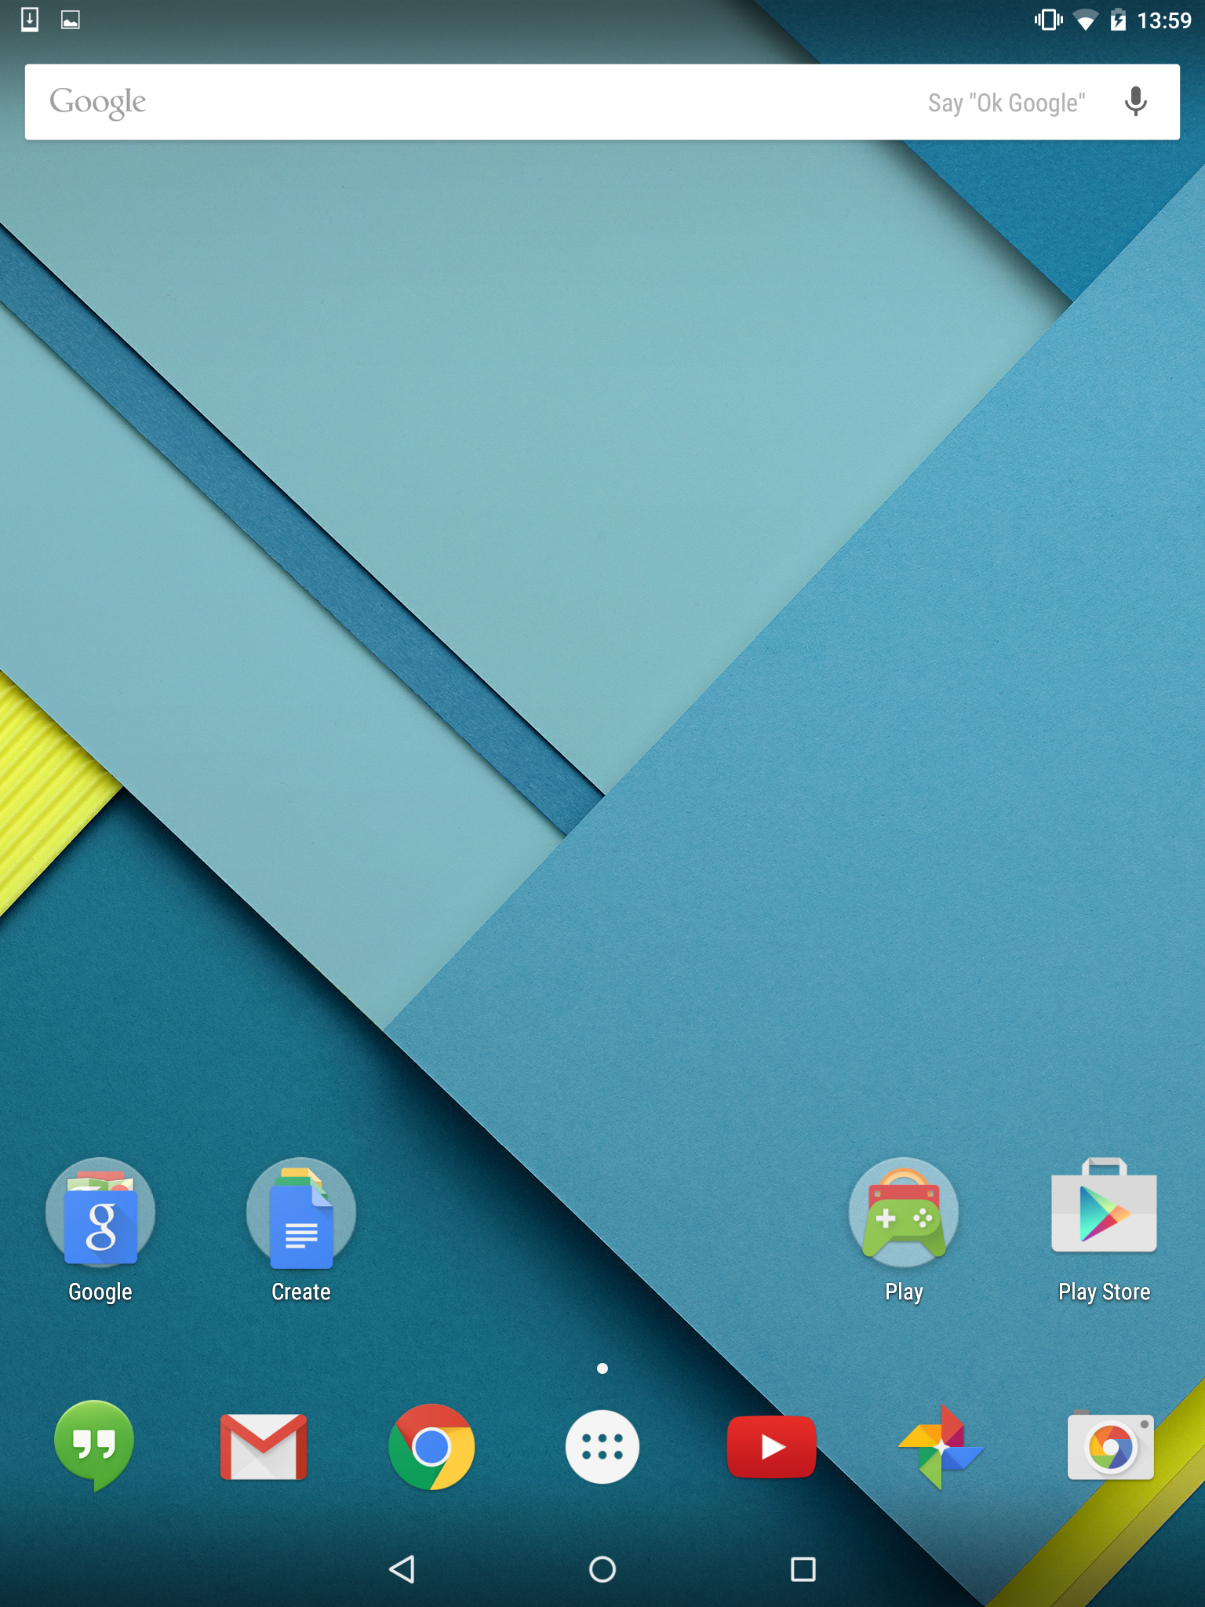

*Menu icon*

* 1. Tap the Settings icon within the menu (shown below).

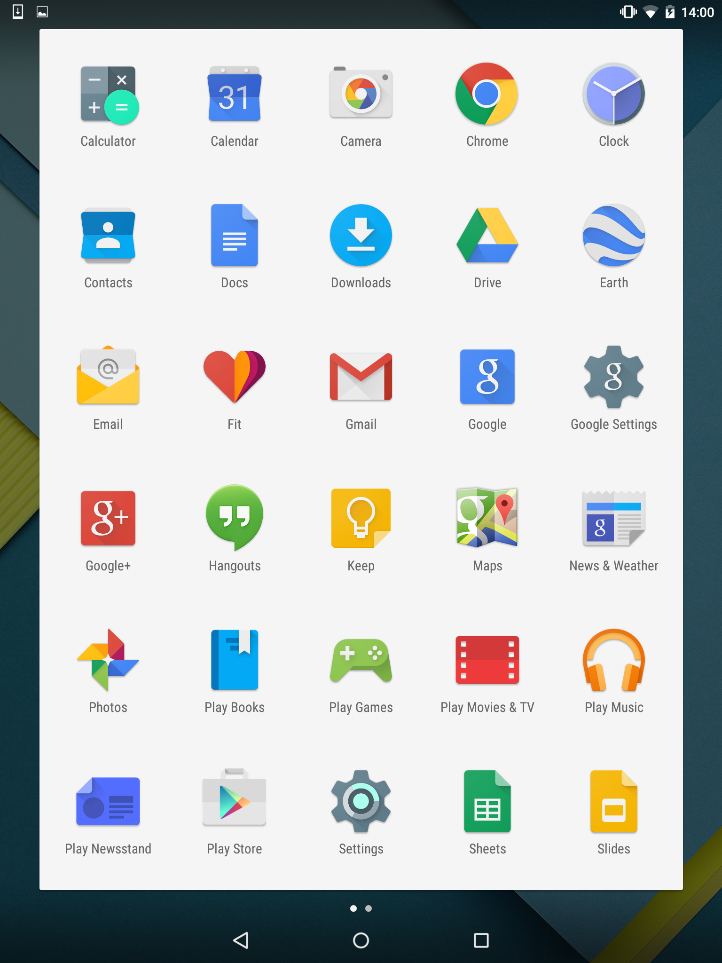

Scroll to the bottom of the Settings screen, and under the “System” section you will see “**About Tablet”. Tap this button.**

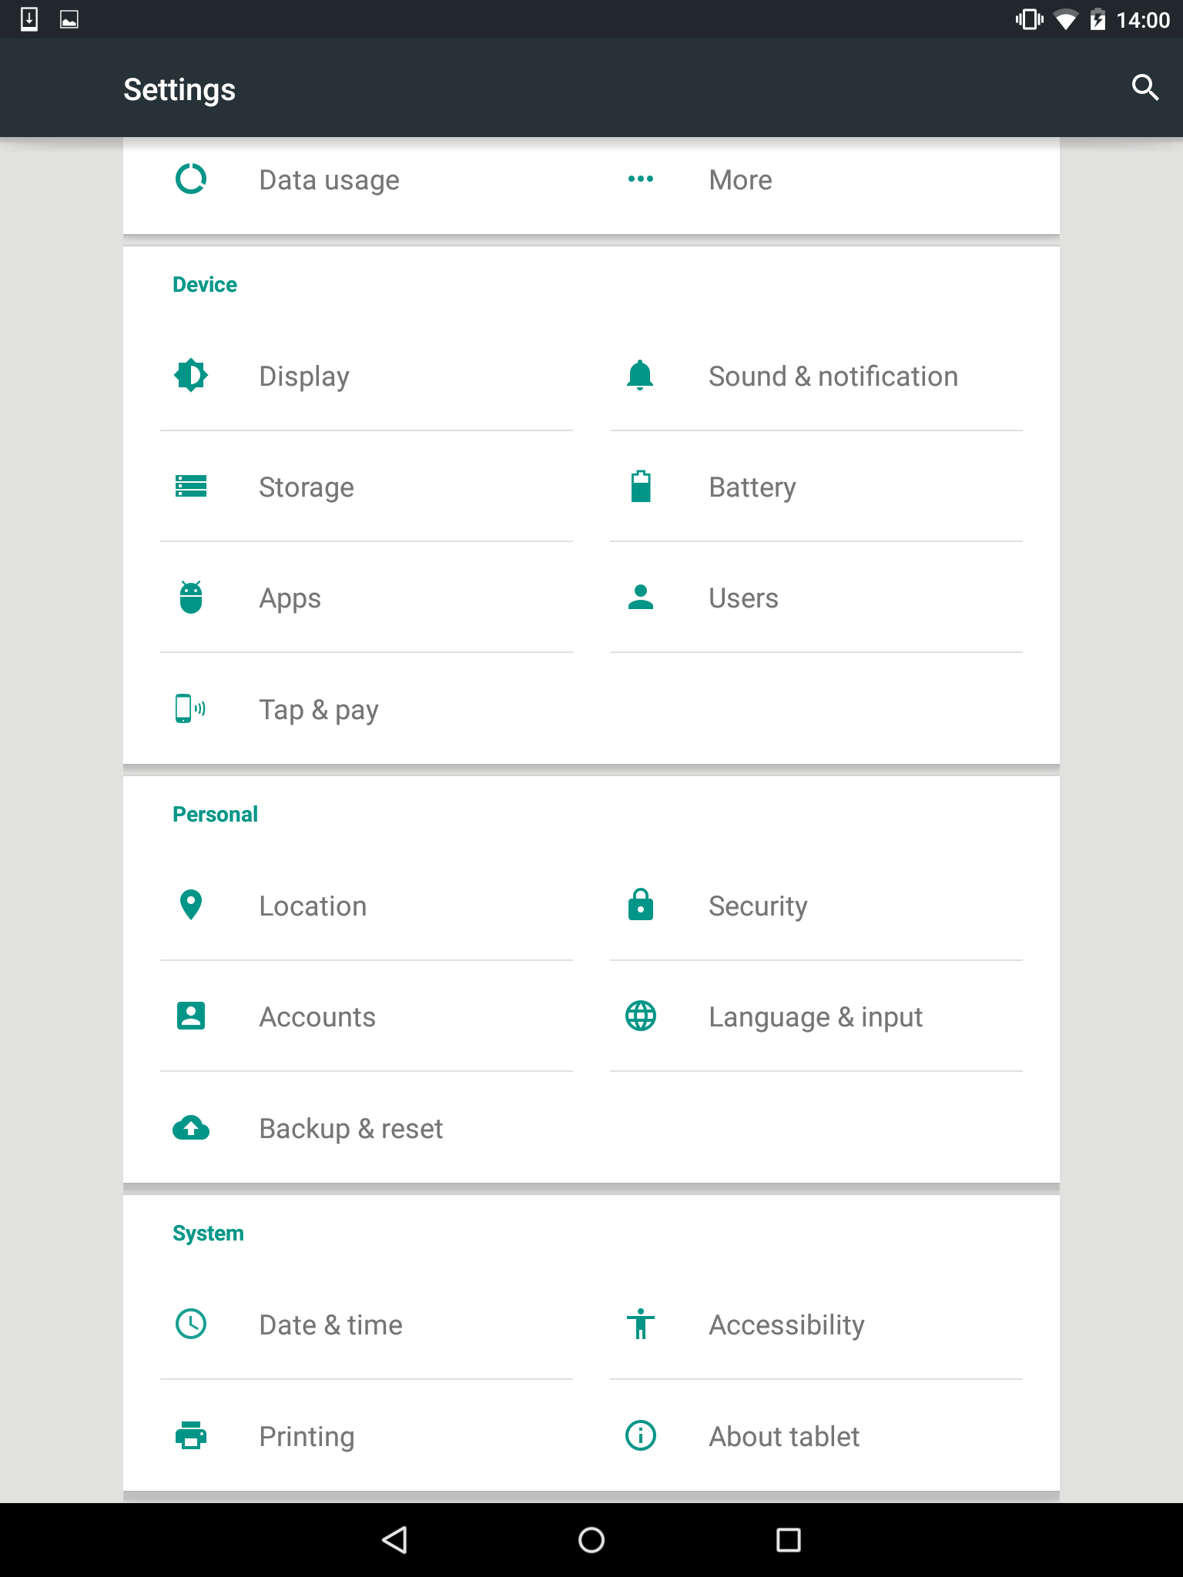

There should be a section in the next table entitled ‘Build Number’. Tap this around 7-8 times, and a prompt should then appear saying – **You are now a developer!**

Return to the main settings application page, and scroll to the bottom of the settings screen and under the System section you will see **Developer options.** Tap this button.

On the next screen, Tick the box next to:

* **Enable OEM unlock**
* **USB Debugging**

Enable OEM unlock – allows you to install the Core system onto the tablet.

USB Debugging – allows the tablet and the Computer to communicate to one another.

Tap the Home button (situated in the middle of the black bar at the bottom)

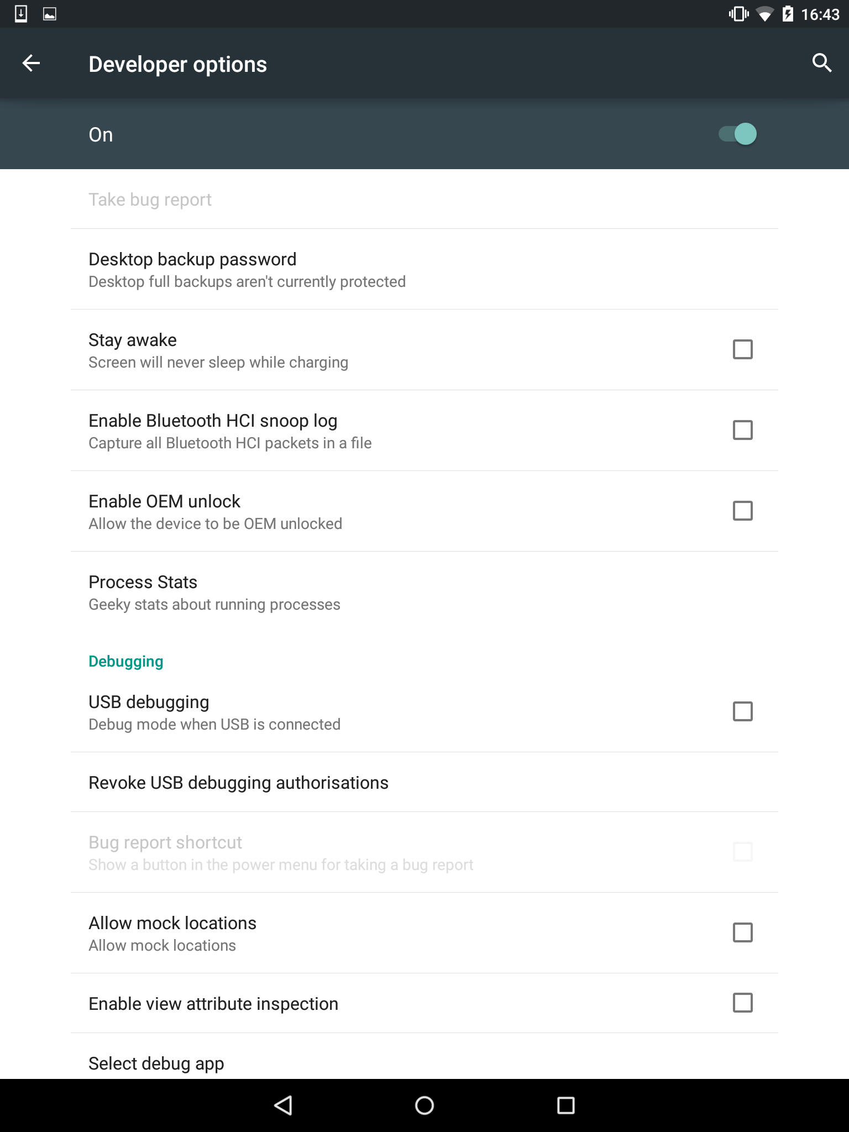

## Connect tablet to Computer via USB Cable

* 1. You should see a USB Debugging popup on screen – tap “OK”.

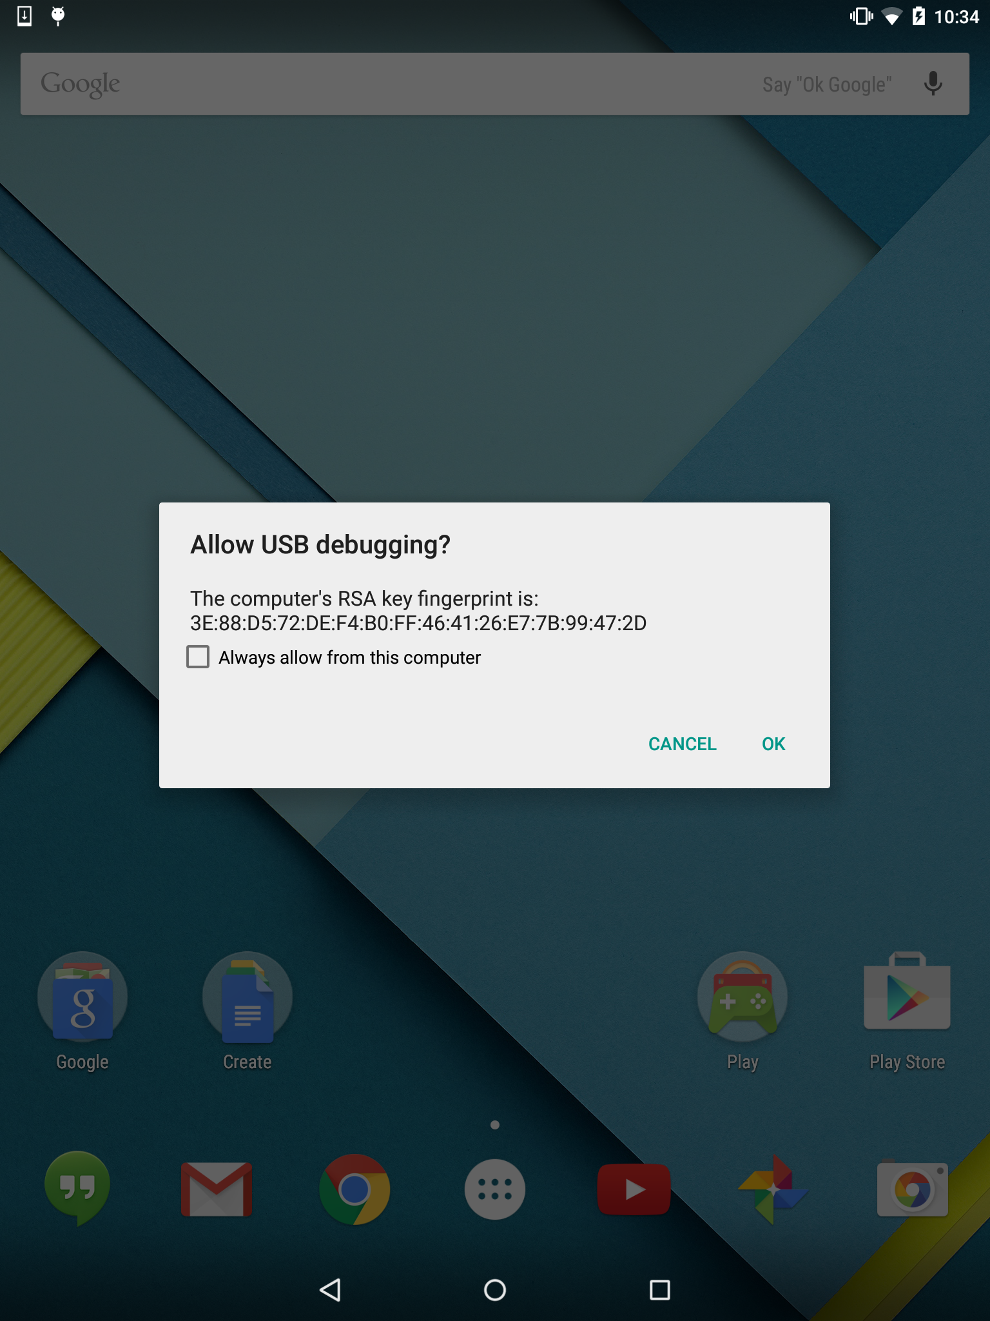

## Start Bootloader

* 1. Open Windows Explorer, and navigate to the **CoreTablets** folder.
  2. Open the **Stock Android Tablet [Retail]** folder

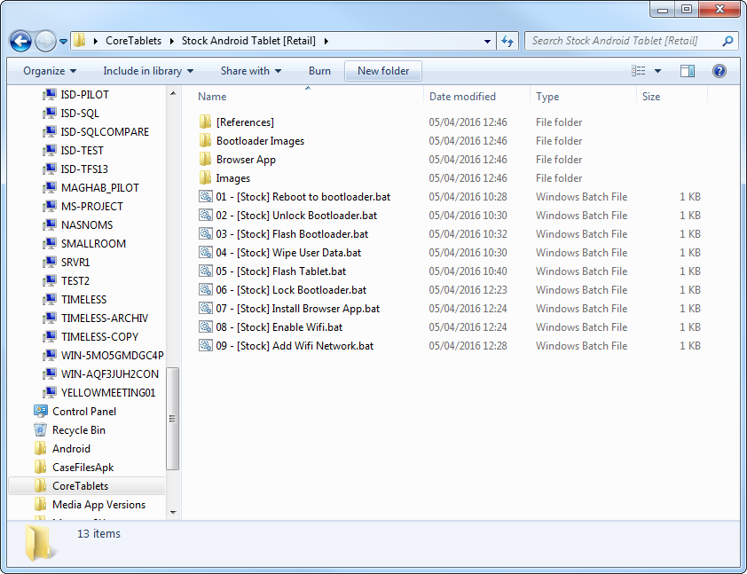

* 1. Double click on the **01 - [Stock] Reboot to bootloader.bat** file

The tablet will turn off and then start up with the bootloader

You should see “FASTBOOT”.

## Unlock Bootloader

In the **Initial Flash** folder:

* 1. Double click on the **02 - [Stock] Unlock Bootloader.bat** file
  2. The tablet should now change to a black screen, confirming yes / no if you want to unlock the bootloader.

Press the Volume Up button to confirm, wait for the device to return to the bootloader

## Flash Tablet

In the **Initial Flash** folder:

* 1. Double click **03 - [Stock] Flash Bootloader.bat** file, the window will alert you that it cannot find a core.zip file, this is nothing to worry about.
  2. Double click **04 - [Stock] Wipe User Data.bat** file
  3. Double click **05 - [Stock] Flash Tablet.bat** file, this may take some times, 60+ seconds to complete, you will see a small green bar on the device bootloader screen during this (top right hand side of the device). It can potentially hang here for a number of reasons outside of our control and in this instance the process should be restarted.

## Factory reset the tablet

The following steps are done on the physical tablet:

* 1. Press the power button to select **HBOOT**
  2. Use the volume up and down buttons to navigate to **FACTORY RESET**
  3. Press the power button to select **FACTORY RESET**
  4. Once tablet has powered on, double click **06 - [Stock] Lock Bootloader.bat,** once complete (you will see a small android icon and the device will eventually return to the bootloader menu) you can select **REBOOT** to restart the device

## Enable network settings

In the **Stock Android Tablet [Retail]** folder:

* 1. Double click the **07 - [Stock] Install Browser App.bat** file, the browser app will now be on the device.
  2. Double click **08 - [Stock] Enable Wifi.bat** file
  3. Double click **09 - [Stock] Add Wifi Network.bat** file, these can be updated and ran later if the wifi network password has changed, please see the end of the document for more information around that. This will add the prison wifi network to the device, ready for auto connection when in range.

# 

# Flashing existing Core Tablet with an updated version of Core system

## Navigate to Core Existing Tablet [Reflashing] Folder

* 1. Open Windows Explorer
  2. Navigate to **CoreTablets** folder
  3. Open **Core Existing Tablet [Reflashing]** Folder

## Open Files for Re Flashing tablet

In the **Core Existing Tablet [Reflashing]** folder:

* 1. Double click the **01 - [Core] Unlock Bootloader.bat** file, you will be taken to the bootloader menu and asked to press volume up in order to proceed, upon pressing volume up you will be reloaded back to the bootloader menu agains
  2. Double click the **02 - [Core] Flash Bootloader.bat** file, again an error is expected here (unable to find core.zip file) this is nothing to worry about.
  3. Double click the **03 - [Core] Wipe User Data.bat** file
  4. Double click the **04 - [Core] Flash Tablet.bat** file, again this is likely to take some time to complete.

## Factory reset the tablet

The following steps are done on the physical tablet:

* + Press the power button to select **HBOOT**
  + Use the volume up and down buttons to navigate to **FACTORY RESET**
  + Press the power button to select **FACTORY RESET**
  + Once tablet has powered on, double click **05 - [Core] Lock Bootloader.bat,** you will be returned to the bootloader menu after a small android icon is displayed on the screen, select **REBOOT** to load up the device.
  + Double click the **06 - [Core] Install Browser App.bat** file
  + Double click the **07 - [Core] Enable Wifi.bat** file
  + Double click the **08 - [Core] Add Wifi Network.bat** file

# The Process Concerning Tablets From New Manufacturers

|  |  |
| --- | --- |
| **Advantages** | **Challenges** |
| Samsung has open-sourced its kernel source code. | Samsung has many proprietary drivers for its hardware. |
| Android has open-sourced its code. | There is little to no existing documentation on compiling AOSP for tablet devices. |
|  | AOSP will be difficult to integrate with Samsung drivers and kernel space. |

In this instance, the target manufacturer is Samsung. This task is made challenging by a few factors:

# Future Steps

There are a few steps required to take this forward:

* Define the features in Android that should be enabled/disabled for each country/locality and document this.
* Disable these defined features within the Android source code.
* Build an image with these features enabled/disabled.

To determine the features that are enabled and disabled in the current Core images, the Stash server should be accessed, and the commits made to each branch of the repository should be read through and the features noted.

The Stash server can be accessed on the internal Core network at: <http://10.0.20.100:7990/projects/ALI/repos/aosp/browse>

The username and password can be found at:

The NCCSoft team have done a very good job of producing a document highlighting what changes they made to the Android source code for the original Core custom image, and this guide should be followed for other ROM manufacturers. Please see References and Appendices for further details on this.

# Appendix: Communication with Samsung

Dear Customer,   
  
Thank you for your continuous interest in our product.   
We have received your request through OSRC web site.   
  
This web site is intended to provide Open Source Software used in our product. Please accept our apology for not being able to handle your request up to your satisfaction.   
We can't confirm which defconfig files you should use for which chipsets (since we are only required to release opensource software to the customer.) but you may need to use defconfig file which is included in requested model and SW version's opensource software published at OSRC site.   
  
If you buy a tablet that contains Sanpdragon 400 chipset, then please send us new request for opensource software for your new tablet model and SW version (firmware version). In this way, you may get proper defconfig file of kernel for your model.   
  
Please, do not hesitate to contact us if you have any other questions regarding Open Source Software.   
  
Thank you.

# Appendix X: Samsung Region Codes for Firmware and Tablet Versions

SAMSUNG REGION CODES (AS IN “TABLET VERSIONT555**XX**U1AOD1”**)**

**BD** Cyprus, Greece  
**CP** Finland  
**DB**Vietnam  
**DC** Thailand  
**DD** India  
**DT** Australia  
**DX** Indonesia, Malaysia, Philippines, Singapore, Vietnam  
**DZ** Malaysia, Singapore  
**JA** South Africa  
**JC** Algeria, Morocco, Nigeria, South Africa, Tunisia  
**JP** Arabic  
**JR** Arabic  
**JV** Algeria, Egypt, Iran, Iraq, Kuwait, Morocco, Nigeria, Oman, Pakistan, Saudi Arabia, South Africa, Syria, Tunisia, Turkey  
**MT** Switzerland  
**XA** Austria, France, Germany, Italy, Netherlands, Switzerland, United Kingdom  
**XB** Denmark, Norway, Sweden  
**XC** Portugal, Spain  
**XD** Croatia, Czech, Hungary, Slovakia  
**XE** Bulgaria, Estonia, Kazakhstan, Latvia, Lithuania, Russia, Ukraine  
**XF** Bulgaria, Croatia, Romania  
**XW** France, Germany, Italy, Netherlands, Portugal, Spain, Turkey, United Kingdom  
**XX** Austria, Belgium, France, Germany, Hungary, Italy, Spain, United Kingdom  
**ZC** China, Hong Kong  
**ZH** Hong Kong  
**ZT** Taiwan

# Appendix: Modifications Made to Source for Existing Core Tab

# INTRODUCTION

This document lists out the general design for communication / message transferring inside Core Systems secured Android architecture.

# ANDROID ARCHITECTURE

## General Android architecture

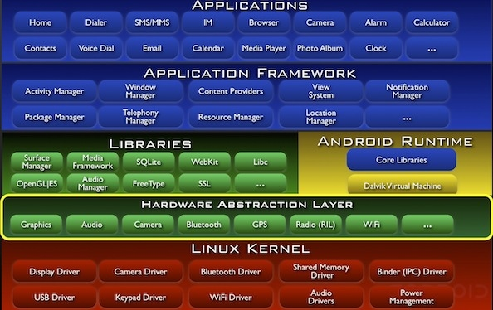

Refer to: <http://www.edureka.in/blog/beginners-guide-android-architecture/>

## Modifications

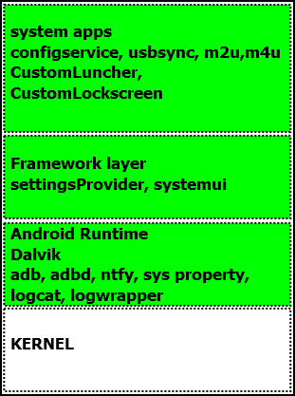

In this section, a brief list out of customization and overview of them is listed out. This is to give a better view and easier way to understand the message flow in later part.

|  |  |  |
| --- | --- | --- |
| Layer | Modification / App | Overview |
| Linux Kernel | N/A | |
| Android Runtime | ADBD | Add token to ADB command.  Root device (modified so that ABD always run in root permission). |
| ADB | Add token to ADB command.  Prevent installation of unknown packages. |
| NTFY | Custom Android Linux process to transfer custom messages between KIOSK and Android Application layer. |
| System Properties | Adjust value of ro.secure for ADB to be run under root permission.  Add key with package name (ex: core.m2u; core.m4u…) to identify the list of approved applications to be installed. |
| Logcat | Utilized to allow communication from Android back to KIOSK thru JDWP. |
| Application Framework | Setting Provider | Modified to manage Inmate ID, Installable and Runnable Packages. |
| Boot Animation | This function creates an image animation when device is under booting. |
| Applications | Configuration Service | Custom service is to receive message from NTFY, parse and execute command.  Call Setting Provider to configure peripheral (Wifi, Bluetooth, Screen rotation…).  Call Setting Provider to set/get Inmate ID.  Order USB Sync App to perform corresponding action. |
| USB Sync | The Android USB sync responsible for synchronizing device properties, digital media purchases and digital media catalogue when a device is connected to a kiosk. |
| Custom Launcher | Custom Launcher only displays necessary information to an inmate. |
| Custom Lock Screen | Shows an inmate`s ID.  Provides time-out mechanism to lock device. |
| Wifi Sync | The environment is initialized to sync via wifi by actively connecting to kiosk via wifi and after the connecting, kiosk will automatically sync with device. |
| Custom Settings | This application can help user change wifi setting, brightness value and show battery, and space available information. |
| OTA Update | OTA update is to load a new ROM or update new features into devices via USB or Wifi. With Wifi feature, device can automatically detect any changing to download ROM. With USB, user needs to put the file into device and execute some commands. |

# COMMUNICATION SEQUENCE DIAGRAMS

## Definition

|  |  |
| --- | --- |
| Object | Description |
| ADBD | ADB Daemon running on Android device. |
| NTFY | Custom ADB shell commands to forward message from KIOSK to Configuration Service. |
| Configuration Service | A custom Android service to listen to message from NTFY as well as from applications (USB Sync, M2U…), translates message then uses Android API to manipulate Android features or serviced. |
| Apps | Android application/service that KIOSK wants to manipulate using NTFY command.  Is the final target of NTFY command. |
| KIOSK | Client PC that has ADB Client installed, and used as work station to perform synchronization. |
| JDWP | Java Debug Wire Protocol.  <http://docs.oracle.com/javase/1.4.2/docs/guide/jpda/jdwp-spec.html> |

## KIOSK – ANDROID communication modal

This diagram is the sequence of communication in Android device when it receives a NTFY command from KIOSK.

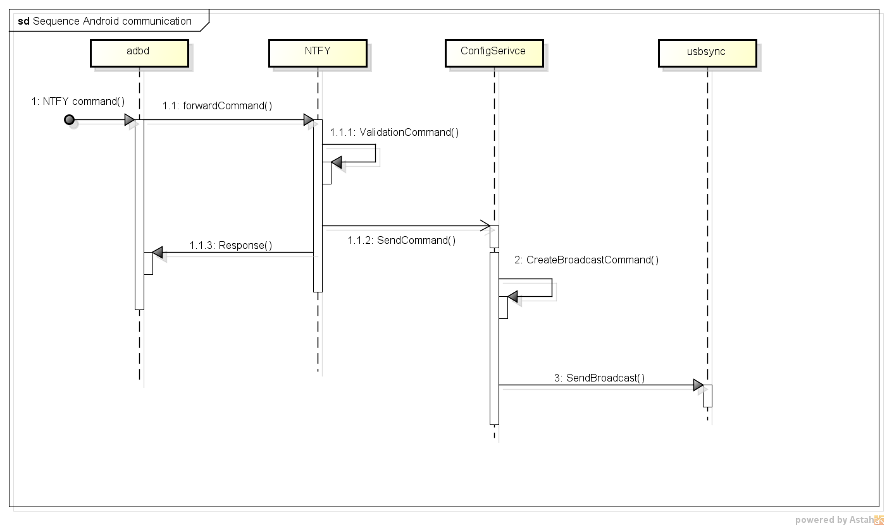

|  |  |
| --- | --- |
| Step | Description |
| 1 | ADBD receives NTFY command, starts a synchronous process. |
| 1.1 | ADBD invokes a new NTFY sub process then forwards the received command to it. |
| 1.1.1 | NTFY sub process validates the command. |
| 1.1.2 | Validation succeeds, NTFS sub process creates an asynchronous command in appropriate format and sends to Configuration Service. |
| 1.1.3 | NTFY returns to ADB the overall result.  Finish the NTFY synchronous sub process |
| 2 | Configuration Service receives command from NTFY sub process above. It parses the message then processes the command depending on each command type.   1. Call Setting Provider to configure peripheral (Wifi, Bluetooth, Screen rotation…) 2. Call Setting Provider to set/get Inmate ID 3. Order USB Sync App to perform corresponding action |
| 3 | Configuration Service sends broadcast message to its target. The target shall receive and perform demanded action. |

## ANDROID – KIOSK communication modal

This diagram shows the sequence of communication from Android device to KIOSK. The message is sent from Android Apps or Service.

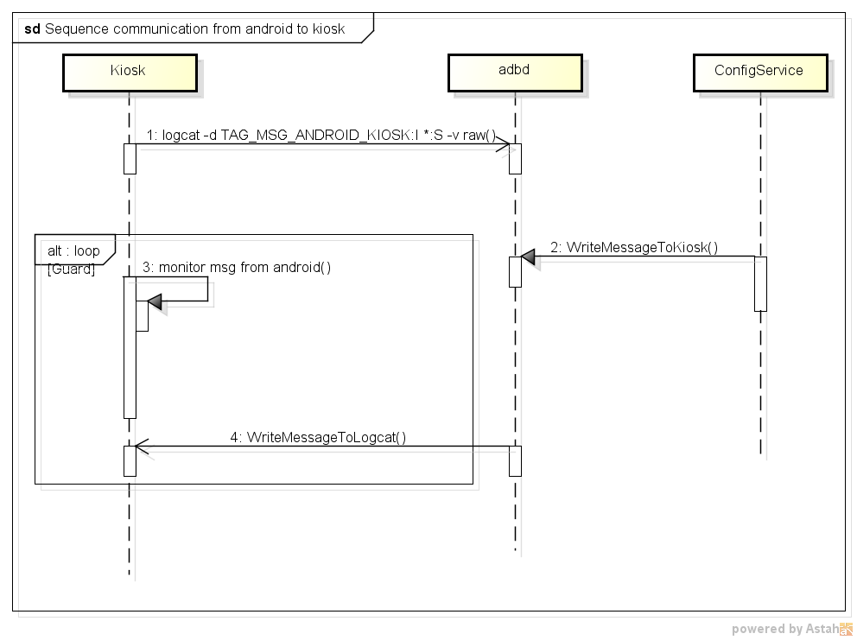

|  |  |
| --- | --- |
| Step | Description |
| 1 | KIOSK initializes the communication by executing a logcat command with the following format:  logcat –d [TAG_MSG_ANDROID_KIOSK]:I *:S –v raw  In which:  -d: indicate that this will work for real device  [TAG_MSG_ANDROID_KIOSK]: Custom tag defines by KIOSKS for ANDROID to use when message is sent back to KIOSK.  :I Indicate that answer from ANDROID should be at information logging level  *:S Indicate that message from all severity level would be accepted  –v raw Indicate that only content of Android message is demanded  After receiving the listening request, ADBD will register a File Descriptor for JDWP (Java Debug Wire Protocol). This is to wait and check any response from Configuration Service, if the same format as request, ADBD shall write/forward back to KIOSK. |
| 2 | When an application/service wants to reply to KIOSK, it shall send broadcast message to Configuration Service.  In turn, Configuration Service shall write that message to listen File Descriptor |
| 3 | On KIOSK, using ADB server, an infinitive loop polls incoming data in blocking mode. |
| 4 | When Configuration Service writes message to logcat. Response Monitor in KIOSK shall recognize that changes. It then parses the message; compare the TAG with the original one that KIOSK wrote to ADBD. If everything success, new event shall be raised accordingly to the command, and other process will take action. |

## Verify device process

This sequence diagram shows the steps to verify and authenticate a Android device

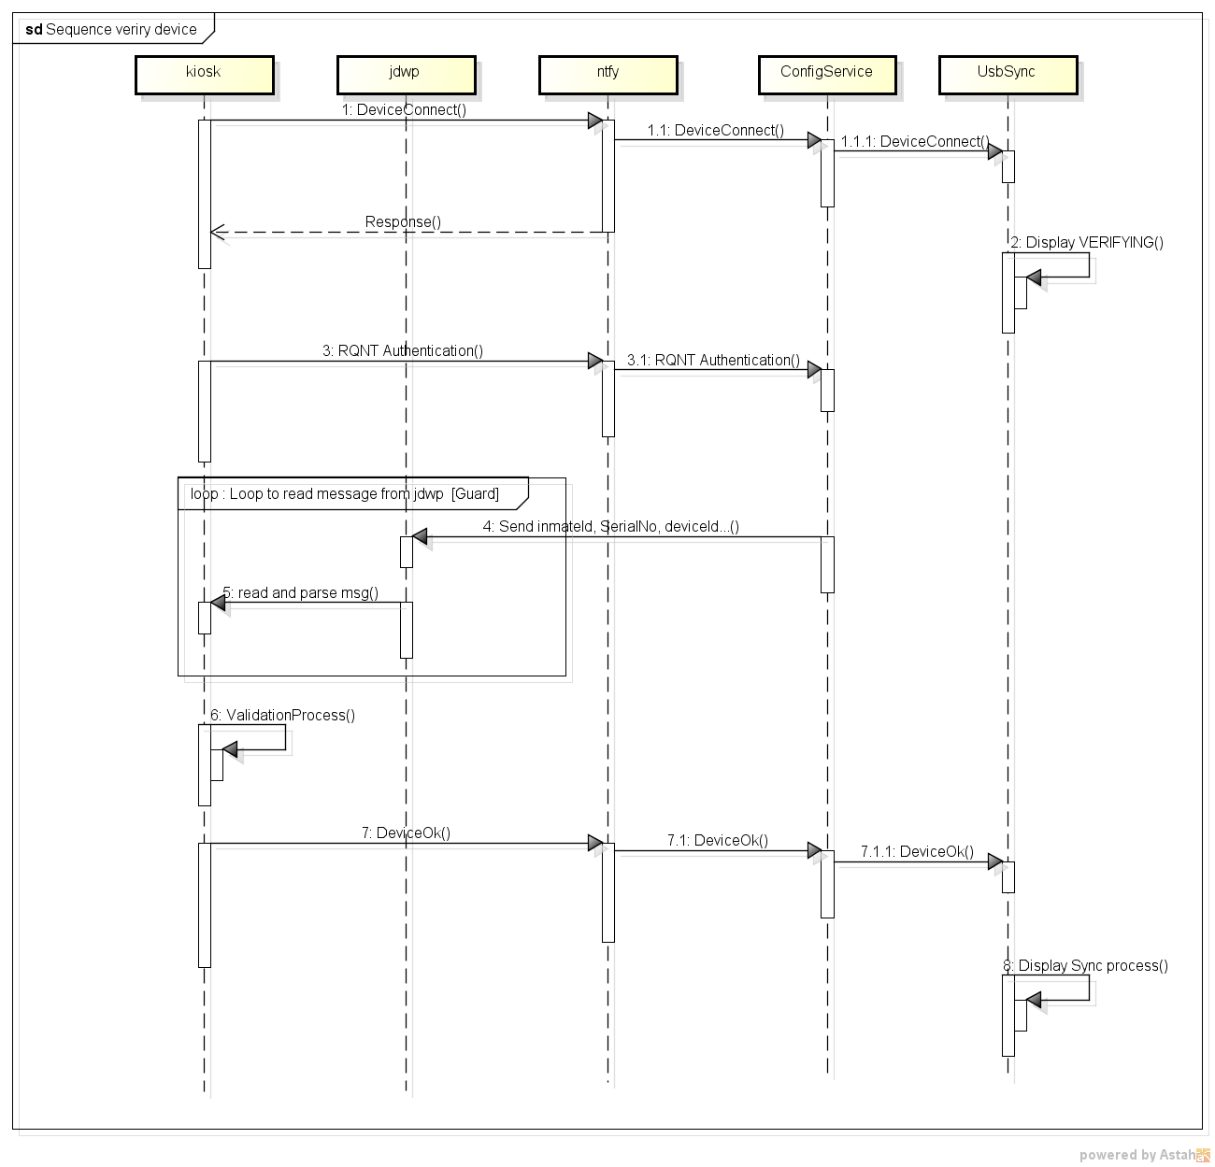

|  |  |
| --- | --- |
| Step | Description |
| 1 | To start connection with Android device, KIOSK will send NTFY DeviceConnect command. Following standard communication process, NTFY and Configuration Service parse the command then call USB Sync App to respond. |
| 2 | USB Sync App receives commands and displays VERIFYING message in the device`s screen. |
| 3, 4, 5 | KIOSK sends NTFY RQNT AUTH command to Configuration Service, which shall get the device`s info (Inmate ID, device Serial Number…). Following Android-Kiosk communication flow, those data is passed back to KIOSK |
| 6 | Validating process in KIOSK is kicked off |
| 7,8 | If validation succeeds, KIOSK will send device sync_mode; sync syncing to start synchronizing.  Else, KIOSK shall send device stolen to lock the Android device |

## Sync process

This is an overview of Sync process for the interaction between KIOSK and an Android device.

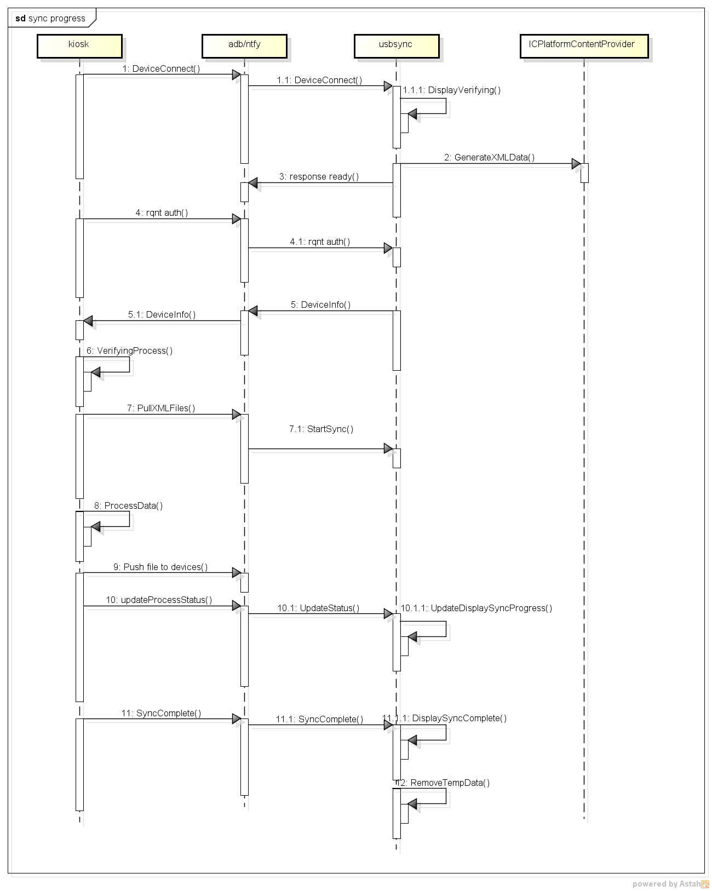

|  |  |
| --- | --- |
| Step | Description |
| 1-6 | Refer to verify device process. |
| 7 | KIOSK sends ADB command to get XMLs the data file (contain output of inmate`s actions such as new messages…). |
| 8 | Process data in KIOSK side. |
| 9 | Push SQLite DB to devices |
| 10 | Send NTFY command to update percentage of complete and status of the sync. |
| 11 | Sync completed, send NTFY to display sync completed. |
| 12 | Remove temporary data of the sync process |

# BASE MODIFICATION

## Configuration Service

## 4.1.1 Overview

Using to communication between IC_Wins and applications (such as UsbSync …) also control mode to communicate and using to control peripheral.

## 4.1.2 Functions

### 4.1.2.1 Communication

- *core.security.config.communication.ChangeConnectionMode.java* to change mode from communication via usb to wifi or from wifi to usb. Other application can send a broadcast *core.security.config.communication.CHANGE_CONNECTION_MODE* with a value command (mode_wifi or mode_usb) to change mode.

- *core.security.config.communication.SendCommand.java* to send command from device to IC_Wins and IC_Wins can receive command via Logcat by logcat filter: *adb -d logcat -v raw command_from_device:I *:S*

- *core.security.config.peripheral.InmateInfoControl.java*, *core.security.config.peripheral.InstallAppsControl.java*, *core.security.config.peripheral.PackageListControl.java* to send command from IC_Wins to device, they will be stored in system property of android device.

*core.security.config.peripheral.InmateInfoControl.java* to save inmate’s id, inmate’s name and booking number. Example command to use it *adb shell ntfy -r"core.security.configservice" -c"inmatectrl inmateId=0A01130;inmateName= Pocolomos;bookingNumber=113" -t"inmateconf"* and after use this command you can see these information show on launcher screen of android device.

*core.security.config.peripheral.InstallAppsControl.java* to set applications can install to device. Example command to use: *adb shell ntfy -r"core.security.configservice" -c"installctrl core.a=1;core.b=1;core.c=1" -t"installconf"* with core.a, core.b, core.c is package name of application want set to install, value to set is 1 or 0 with 1 is allow install and 0 is disallow install.

*core.security.config.peripheral.PackageListControl.java* to set applications that have installed can show shortcut in launcher application. Also this command can remove shortcut, change name of application and add param for shortcut. Example command to use: *adb shell ntfy -r"core.security.configservice" -c"packagesctrl packagename=core.systems.settings#title=Message to U#param=param1" -tpackagesconf*

*adb shell ntfy -r"core.security.configservice" -c"packagesctrl remove=core.systems.settings" -tpackagesconf*

### 4.1.2.2 Control peripheral

- *core.security.config.peripheral.AirplanemodeControl.java* to enable or disable air plane mode on device.

- *core.security.config.peripheral.AutoRotationControl.java* to enable or disable auto rotation on device.

- *core.security.config.peripheral.Bluetooth.java* to enable or disable Bluetooth on device.

- *core.security.config.peripheral.Brightness.java* to set value for brightness.

- *core.security.config.peripheral.SoundControl.java* to mute or not for micro phone and speaker.

- *core.security.config.peripheral.WifiControl.java* to enable or disable wifi on device.

- *core.security.config.peripheral.WifiSaveConfiguration.java* to save wifi configuration to device.

- *core.security.config.peripheral.WifiConnectConfiguration.java* to save wifi configuration to device and make device reconnect to this configuration.

## ADB Access

## Overview

Adb is an important tool to help android device to communicate with kiosk. It’s provided by Google in android source code but we need change it to add some features for the lockdown.

## 4.2.2 Functions

### 4.2.2.1 Login

Each device has a password what is provided by officer. This password needs to help ADB to connect kiosk to device. Kiosk wants to connect to a device, it needs login first with password. If password does not match, all communication will be rejected.

Command to login: *adb login 100409* (with *100409* is password of device that wants to connect).

After this command, ADB gets password from field “*dev_passwd_inmate*” of table “*inmate*” of database *“/data/data/core.icplatform/databases/OfflineInfocenter.db*” then compares with “*100409*”; if matched, ADB will return login succeeded and after that all other ADB command will be used as normal.

Note: if database *“/data/data/core.icplatform/databases/OfflineInfocenter.db*” does not exist, any password is accepted.

### 4.2.2.2 Check key

ADB run on kiosk needs a key file with name “*adbkey.pub*” that contains a key matched with the key is set in ADB (can see it at folder *system/core/adb,* file *adb_auth_client.c*). If this key does not exist, the ADB cannot work.

### 4.2.2.3 Prevent USB mass storage

Usb has some modes, like ADB, mtp, and mass storage. ADB mode is to prevent mass storage; and the popup screen is displayed when the device connect to kiosk via usb.

Implement: in folder *system/core/adb*, file *adb.c*, method *adb_main()*, add *property_set("persist.sys.usb.config", "adb");*

### 4.2.2.4 Always run as root

Android provides users: root, system, shell and application. With the original source code, ADB is run under shell permission. This implement is to have root run by default.

Implement: folder *system/core/adb*, file: Android.mk, *Set LOCAL_CFLAGS += -DALLOW_ADBD_ROOT= 1*

### 4.2.2.5 Support wifi connect

In original source code of android, ADB can work on loopback mode only. Its limit is device cannot actively connect kiosk. Hence, the source code is customized to work in INET mode.

Implement: folder *system/core/adb*, file: *adb.c*; replace *ret = socket_loopback_server(port, SOCK_STREAM);* by *ret = socket_inaddr_any_server(port, SOCK_STREAM);*

### 4.2.2.6 Prevent install application

This function prohibits users installing apps into devices. Source code is adjusted in ADB client to check if the package name is set in system property; it will be passed. Otherwise, it will be falsed.

Implement: folder *system/core/adb*, file *core_decodeapk.cpp* and *file_sync_client.c*

*#if defined (CORE_MODICATION)*

*if (verifyApk && !S_ISDIR(st.st_mode)) {*

*int len = 0;*

*char bufcmd[MAX_PROP_VAL_LEN] = {0,};*

*char packvalue[MAX_PROP_VAL_LEN] = {0,};*

*char* package_name = get_package_name(lpath);*

*if (package_name == 0) {*

*fprintf(stderr, "AndroidManifest.xml in '%s' does not contain package name \n", lpath);*

*return 1;*

*}*

*snprintf(bufcmd, sizeof(bufcmd), "shell:getprop %s %d", package_name, 0);*

*free(package_name);*

*len = read_shell_service(bufcmd, packvalue);*

*if (!len) {*

*fprintf(stderr, "%s installed error\n", lpath);*

*return 1;*

*}*

*if (strncmp(packvalue, "1", 1) != 0) {*

*fprintf(stdout, "%s is not allowed to install in this device", lpath);*

*return 1;*

*}*

*}*

*#endif*

## NTFY Commands

Device and kiosk communicate with each other by using NTFY Commands.

Implement: folder *system/core/ntfy.*

## Downgrade openssl from 4.2.2 to 4.1.2

This function is to authenticate adb by using login and check- key functions above.

Implement: in folder: *external,* replace *openssl* of version 4.1.2 by of that version 4.2.2.

## Changes for standard API

In original source code, a few APIs are hidden from the application layer and only framework layer is allowed to use it. However, some Core System`s apps need to use some of the hidden APIs, hence changes for standard API is needed.

Implement:

Change *frameworks/base/core/java/android/app/StatusBarManager.java*

Change *frameworks/base/core/java/android/content/Context.java*

Change *frameworks/base/core/java/android/os/SystemProperties.java*

Change *frameworks/base/core/java/android/provider/Settings.java*

Note: after change these files, need using command "*make update-api*"

## Help UID system read SD Card

By default, system users have no permission on SD Card, the permission value is *000*. As a result, SD card`s permission is adjusted from *000* into *0750*; so, some apps running under system users can be executed.

Implement:

Change *system/core/rootdir/etc/init.goldfish.rc*

Change *device/asus/grouper/init.grouper.rc*

# LOCKDOWN FUNCTIONALITY

## Add ROM version

ROM`s information needs to be updated.

Implement: change *build/core/Makefile*

## Prevent hard-key and long press hard-key

This function is to prevent users using hard-keys, such as power, home, back and recent buttons.

Implement:

Change *frameworks/base/services/input/InputDispatcher.cpp*

Change *frameworks/base/policy/src/com/android/internal/policy/impl/PhoneWindowManager.java*

## Prevent installation app

This function is to prevent users installing apps.

Implement:

Using C: mentioned in 4.2.2.6 Prevent install application.

Using Java: Change *packages/apps/PackageInstaller/src/com/android/packageinstaller/PackageInstallerActivity.java*

Change *frameworks/base/core/java/android/os/SystemProperties.java* (Note: after change this file, need using command "*make update-api*" before "*make -4j*")

## OTA Update

OTA update is to load a new ROM or update new features into devices via USB or Wifi. With Wifi feature, device can automatically detect any changes then download ROM. With USB, user needs to put the file into device then execute some commands.

Implement:

Add *packages/apps/OTAUpdate*

Add *OTAUpdate* in *PRODUCT_PACKAGES* of file *build/target/product/core.mk*

Commands to update via usb:

*adb push path/to/file /sdcard/OTA-Update/download/ROM/update.zip*

*adb shell ntfy -r"core.security.configservice" -c"update /sdcard/OTA- Update/download/ROM/update.zip" -t"updateconf"*

## Removal of standard applications

This function is to delete default apps of android.

Implement:

In file *build/target/product/core.mk* remove apps: Browser, Contacts, DownloadProviderUI, Home, HTMLViewer

In file *build/target/product/full_base.mk* remove apps: VideoEditor

In file *build/target/product/generic_no_telephone.mk* remove apps: DeskClock, Bluetooth, Calculator, Calendar,

In file *build/target/product/full_base_telephony.mk* remove apps: VoiceDialer

In file *build/target/product/sdk.mk* remove package development/apps/Development to remove apps: Dev Tools

# CUSTOM APPLICATIONS

## BootAnimation

This function creates an image animation when device is under booting.

Implement:

Change *build/target/product/full_base.mk*

Add *frameworks/base/data/bootanimation/BootAnimation.mk*

Add *frameworks/base/data/bootanimation/bootanimation.zip*

Note: when file zip *bootanimation.zip* is created, using compression level *Store* ismandatory.

## Custom Launcher

This application shows shortcut of all other applications and displays inmate`s information.

Implement:

Add *packages/apps/CustomLauncher*

Add *CustomLauncher* in *PRODUCT_PACKAGES* of file *build/target/product/core.mk*

Main class: *com.coresystems.customlauncher.PageViewActivity.java* is main activity of CustomLauncher. This class use *android.app.StatusBarManager* to hide all buttons such as back, home, recent buttons and hide some notifications too. Also this activity gets all package names of application allowed to display on launcher screen. This list of packages is set by a command from kiosk (please see 4.1 Configuration service, PackageListControl.java above to have more detail about command to set display applications).

*com.coresystems.customlauncher.AppChangeReceiver.java* is a broadcast receiver, it receives package list to display on launcher screen from the command and save to share preference. This class also receives all changes of the package, such as installing new application or removing an application in a device. When the package changes, this class will call to *com.coresystems.customlauncher.PageViewActivity.java* to update shortcut on launcher screen.

## Custom Lock Screen

This application displays inmate information and locks screen with user’s password.

Implement:

Add *packages/apps/CustomLockScreen*

Add *CustomLockScreen* in *PRODUCT_PACKAGES* of file *build/target/product/core.mk*

## Custom Settings App

This application can help user change wifi setting, brightness value and show battery, and space available information.

Implement:

Add *packages/apps/CustomSettings*

Add *CustomSettings* in *PRODUCT_PACKAGES* of file *build/target/product/core.mk*

# SYNCING WITH KIOSK

## USB Sync

The Android USB/Wifi sync is responsible for synchronizing device properties and application data when a device is connected to a kiosk via USB or Wifi.

Implement:

Add *packages/apps/UsbSync*

Add *UsbSync* in *PRODUCT_PACKAGES* of file *build/target/product/core.mk*

Main class: *core.d2i.usbsync.app.CountdownTimer.java* is broadcast receiver, it is registered to broadcast receiver *android.intent.action.BOOT_COMPLETED* to know when device starts then start service of Usb Sync App.

*core.d2i.usbsync.app.DeviceControl.java* is broadcast receiver to check when device connect or disconnect into kiosk via usb and wifi.

*core.d2i.usbsync.app.DevicePropertyFile.java* is the class to write or read all properties of Usb Sync Application. Also it is implemented a broadcast receiver to receive all command/message from Configuration Service to Usb Sync.

*core.d2i.usbsync.app.FSM.java* is the very important class, it controls all status of Usb Sync and decides messages displaying to user.

*core.d2i.usbsync.service.InteruptHandler.java* is main service of Usb Sync. It controls the countdown timer and main status of device, such as plug, unplug , or stolen status.

## WIFI Sync

The environment is initialized to sync via wifi by actively connecting to kiosk via wifi and after connecting, kiosk will automatically sync with device.

Implement:

Add *packages/apps/WifiSync*

Add *WifiSync* in *PRODUCT_PACKAGES* of file *build/target/product/core.mk*

# CUSTOMIZATION FOR NEXUS 7 (THIS WILL NEED TO BE CHANGED FOR SAMSUNG TABS)

## Add Asus driver for Nexus 7

Implement:

*extract-broadcom-grouper.sh, extract-elan-grouper.sh, extract-nvidia-grouper.sh, extract-nxp-grouper.sh, extract-widevine-grouper.sh* to android source code folder

Change permission of 5 files *.sh* in 17.1 of *changes.txt* to *777* (ex: *chmod 777 extract-broadcom-grouper.sh*)

Run 5 files *.sh* in 17.1 of *changes.txt* to set up driver (ex: *./extract-broadcom-grouper.sh*) then follow by information on screen to install them (tip: Enter then keep space button on keyboard then type I ACCEPT then Enter). After that vendor folder will be created.

# Block settings button on keyboard default

This function to block settings button on keyboard default of android, so user cannot change input method.

Implement:

Changes file *packages\inputmethods\LatinIME\java\src\com\android\inputmethod\latin\LatinIME.java*

# Prevent notification bar

This function to prevent notification bar, so user cannot swipe down on status bar to show notification bar and block settings button on status bar.

Implement:

Changes file *frameworks\base\packages\SystemUI\src\com\android\systemui\statusbar\phone\PhoneStatusBar.java*

Changes file *fileframeworks\base\packages\SystemUI\src\com\android\systemui\statusbar\phone\StatusBarWindowView.java*

Changes file *frameworks\base\packages\SystemUI\src\com\android\systemui\statusbar\phone\PhoneStatusBarView.java*

Changes file *frameworks\base\packages\SystemUI\src\com\android\systemui\statusbar\tablet\TabletStatusBar.java*

# References

<http://graemehill.ca/compiling-permissive-android-kernel/>